**1) Create a Linux VM and host a sample website given in below link**

<https://github.com/learning-zone/website-templates/tree/master/above-educational-bootstrap-responsive-template>

//******************** **Create and deploy Kubernetes Engine** ********************//

Step 1 : Find a github repository for hosting the website : https://github.com/learning-zone/website-templates

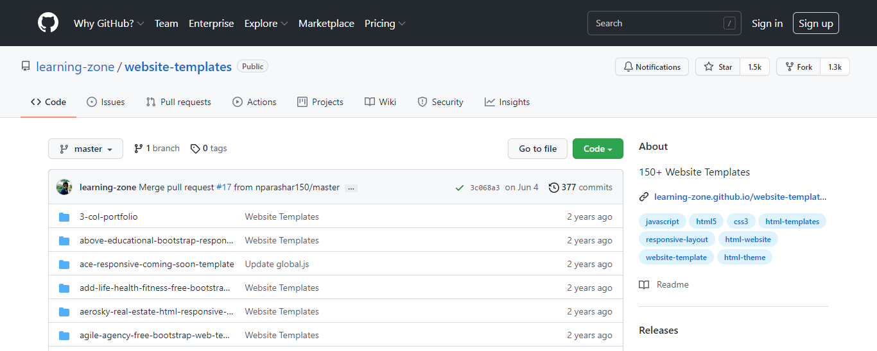

Step 2 : Open the cloud shell and make a directory ‘temp’.

Step 3 : Inside that directory clone the github site using git clone command and then go to the path of github repository which contains the required files.

Step 4 : Create a container using docker run command and view the running containers by using docker ps

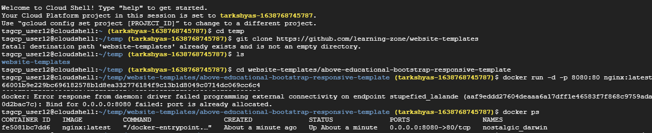

Step 5 : Copy all the files insides github repository to the container by using docker cp command : docker cp about.html fe5081bc7dd6:/usr/share/nginx/html/

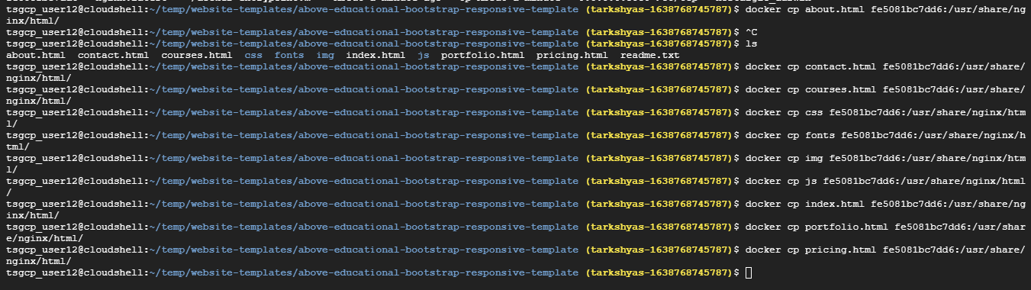

Step 6 : Then commit docker inorder to allow users to take the running container and save its current state as an image : docker commit fe5081bc7dd6 testsite:version1

Step 7 : Share those images to the Docker Hub registry using docker push :

docker tag testsite:version1 us.gcr.io/ tarkshyas-1638768745787/testsite:version1

docker push us.gcr.io/ tarkshyas-1638768745787/testsite:version1

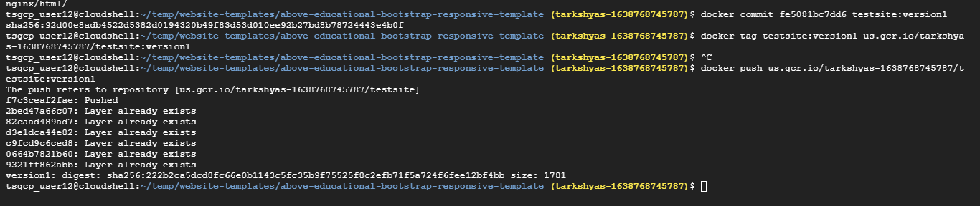

Step 8 : Go to the container registry and view the image created

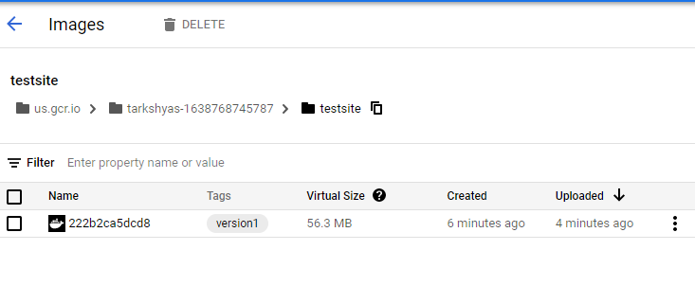

Step 9 : Open Workloads in Kubernetes Engine and deploy the application

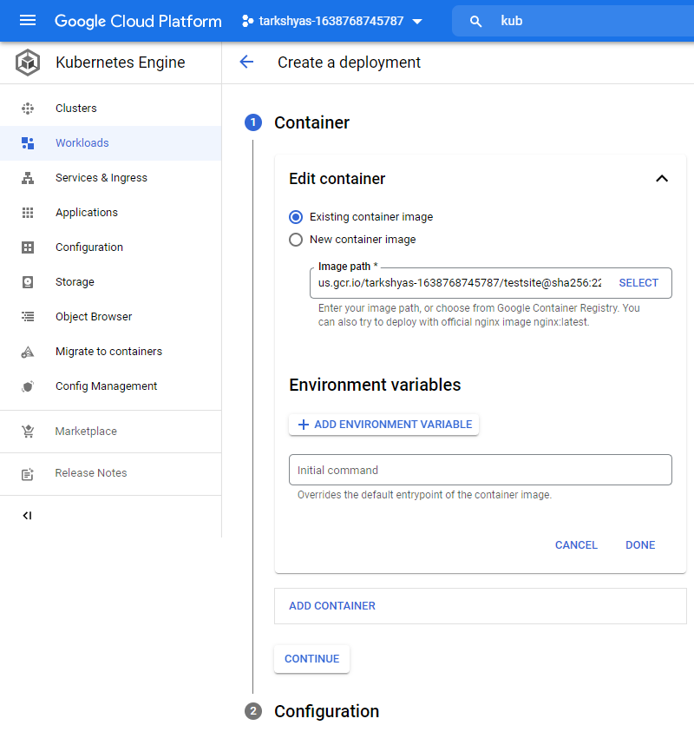

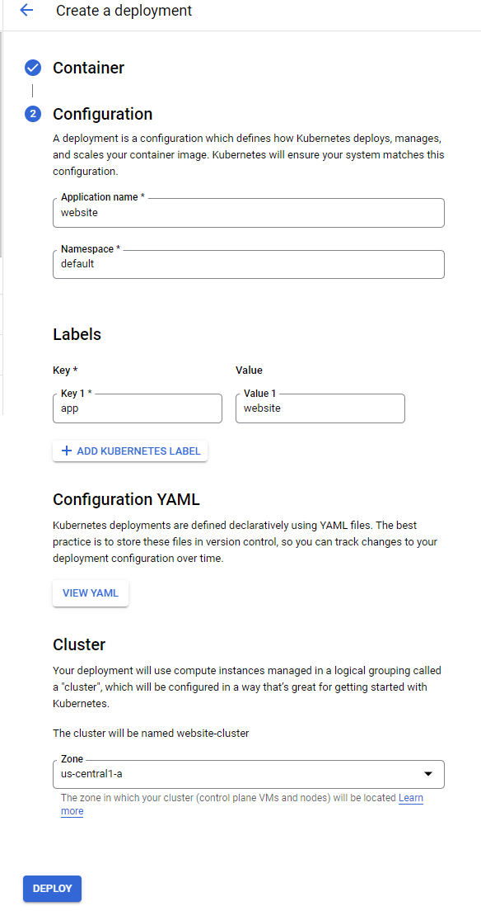

Step 10 : Expose the deployed application

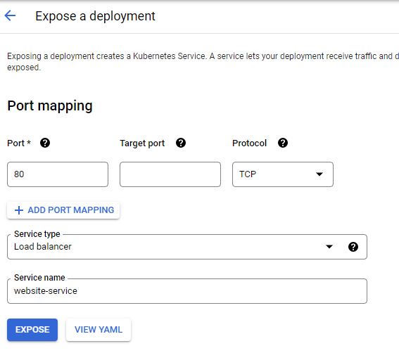

Step 11 : After deployment and expose

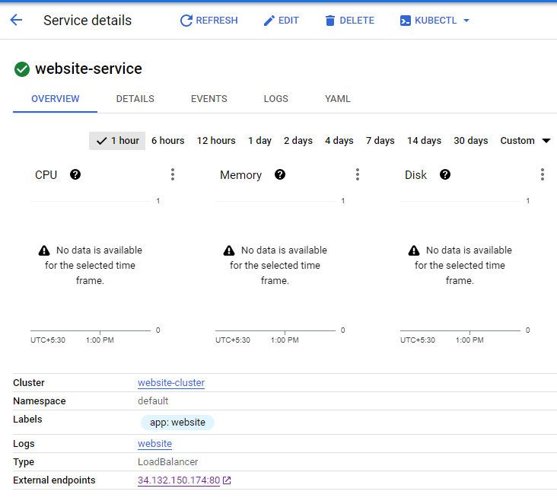

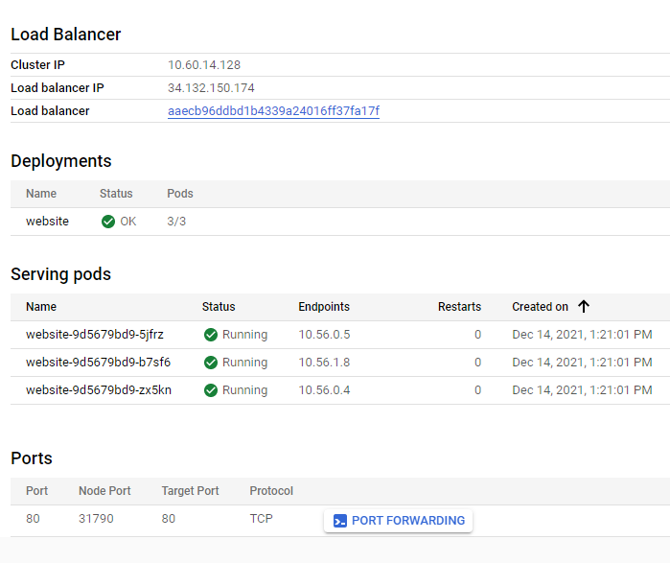

Step 12 : By clicking on external endpoints we get the required website

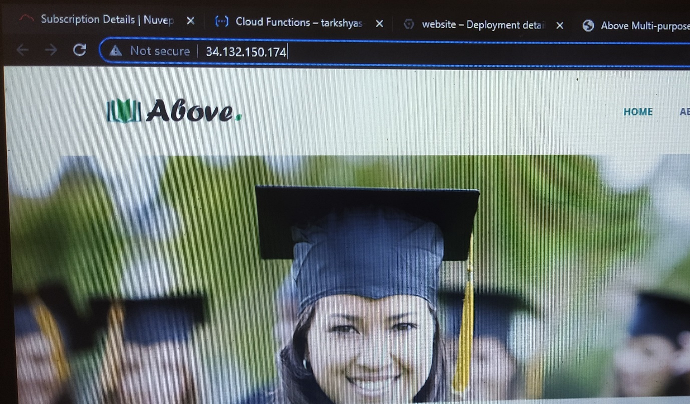

//****************************** **Create VM** *******************************//

Step 13 : Create a VM instance with configure container by giving the container image URL in the container registry

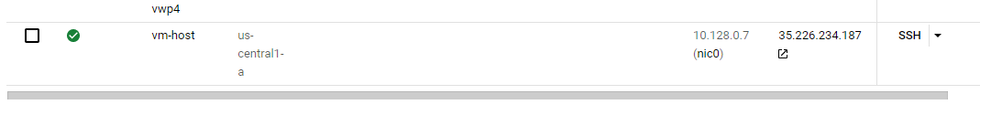

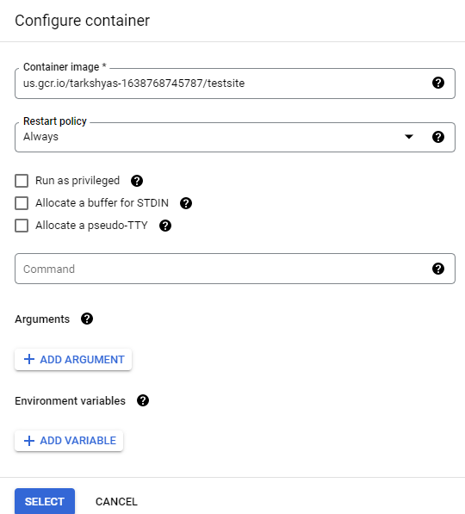

Step 14 : Copy the external ip address of created VM and paste in the browser which leads to the particular site



**2) Create a VPC network to communicate between 2 VM instance in different networks.**

Step 1 : Create two VPC networks in different regions , vpn-asiasouth1 and vpn-uscentral1

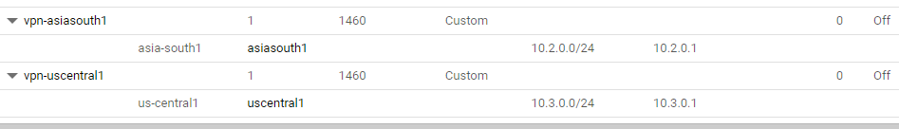

Step 2: Set firewall rules for both networks.

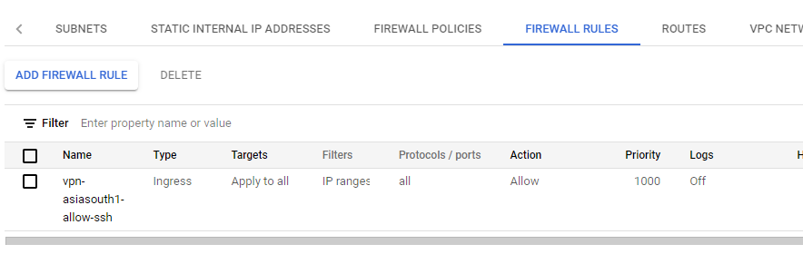

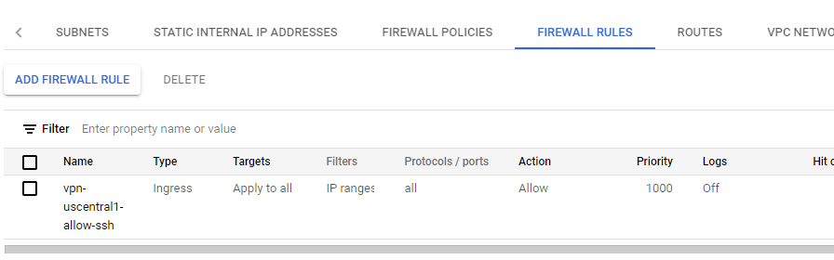

Step 3: Create VM instance for VPC network in asiasouth1 with Networking field as follows

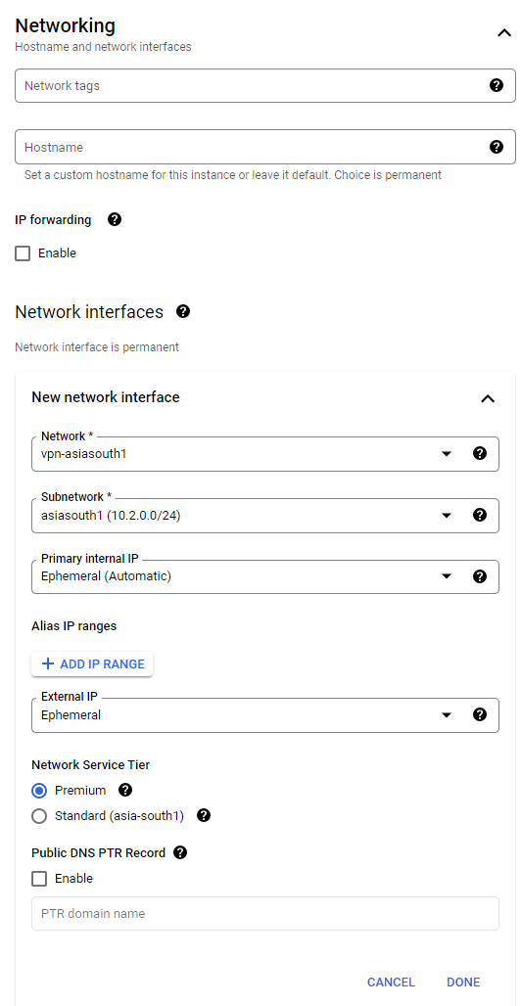

Step 4: Create VM instance for VPC network in uscentral1 with Networking field as follows

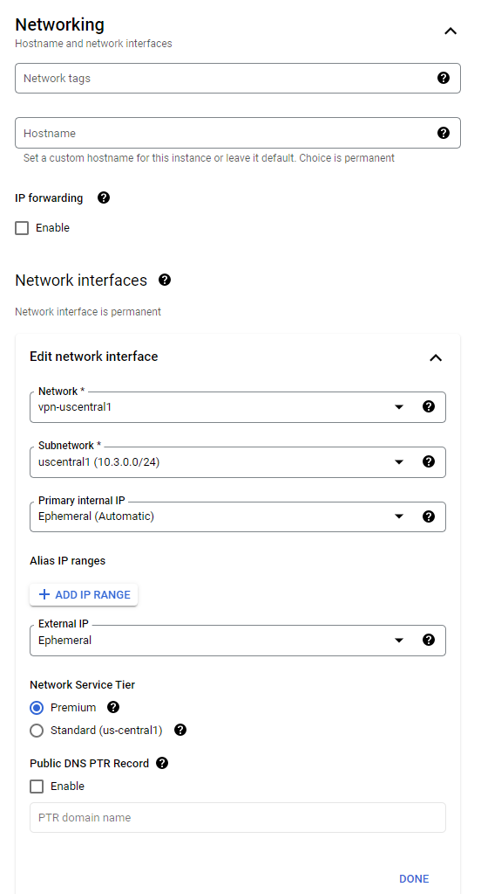

Step 5 : VM instance created for both networks

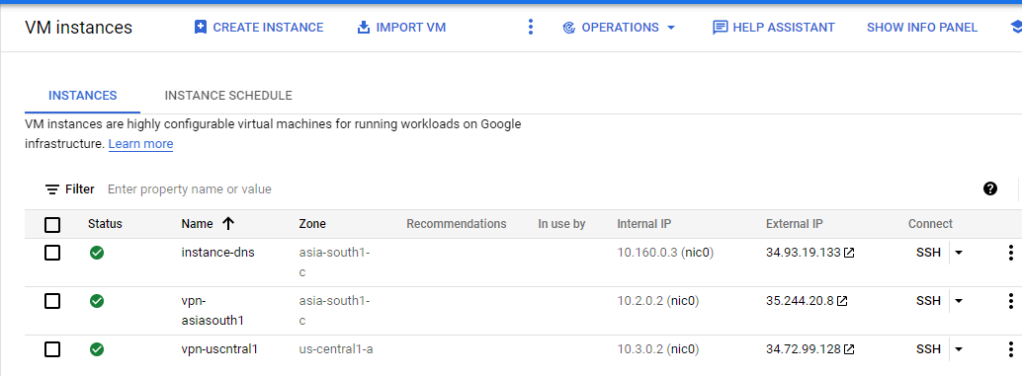

Step 6 : Try to establish connection between these two networks by clicking on SSH and ping.

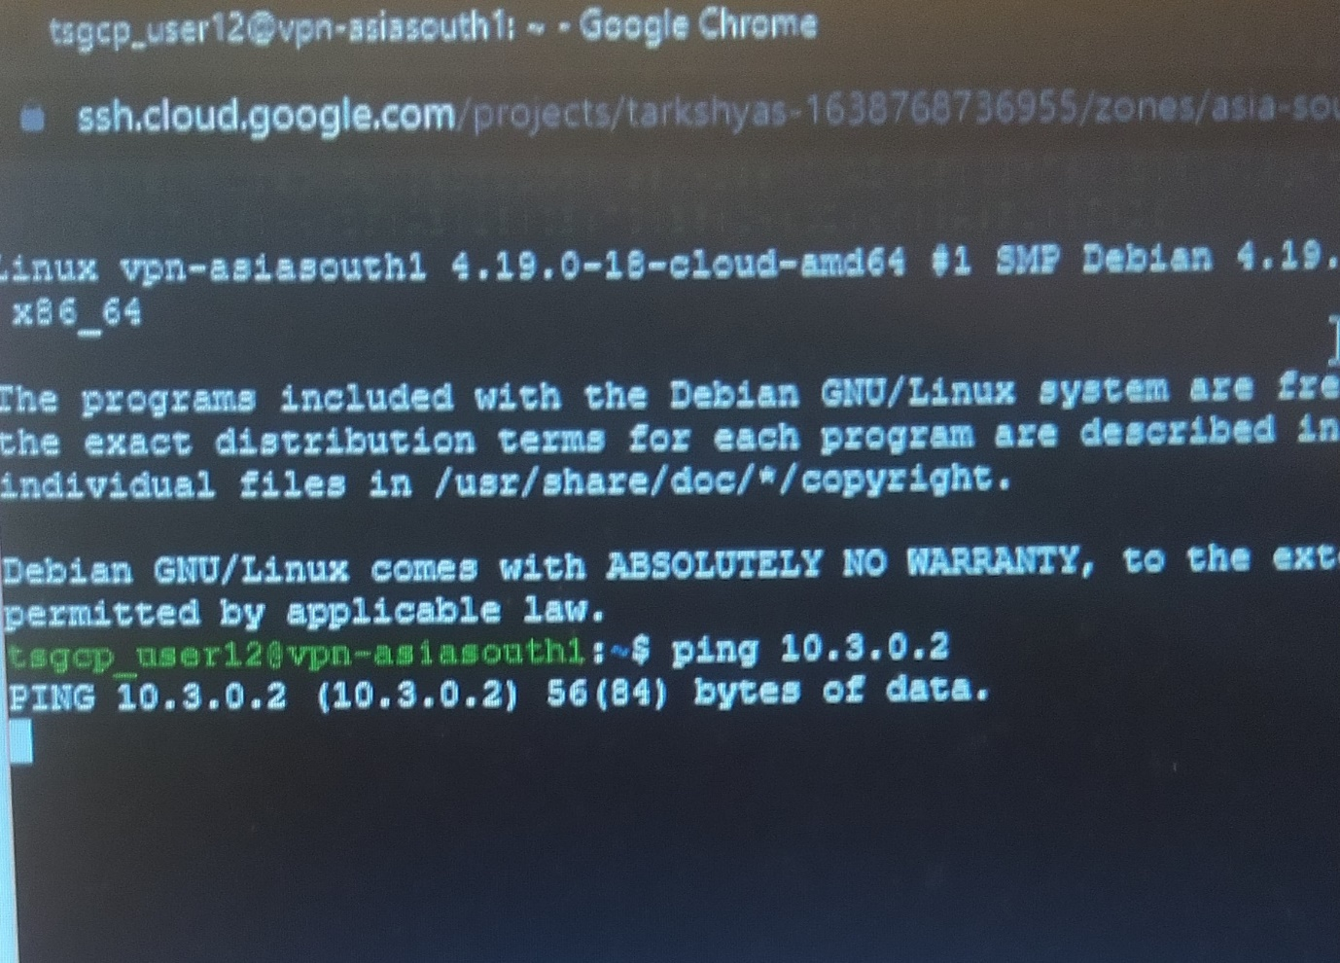

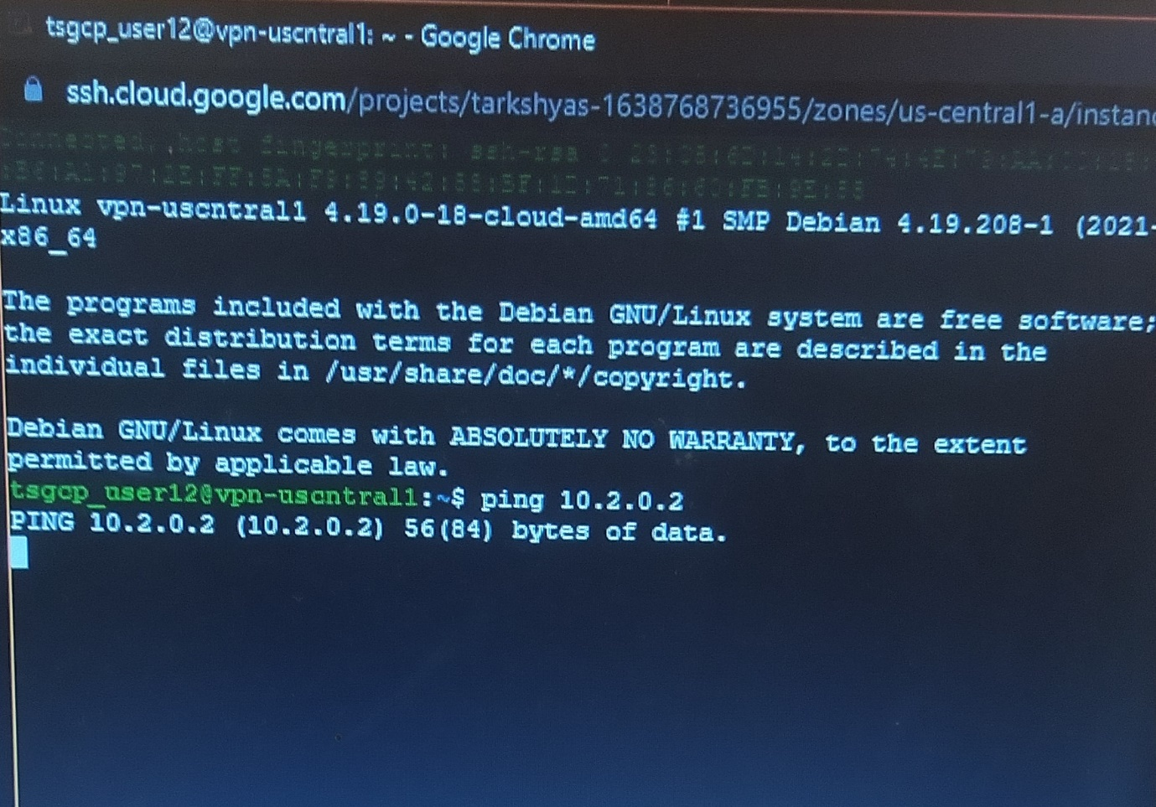

Here the connection fails. So inorder to establish connection, follow the below steps.

Step 7 : Reserve external IP address for both networks.

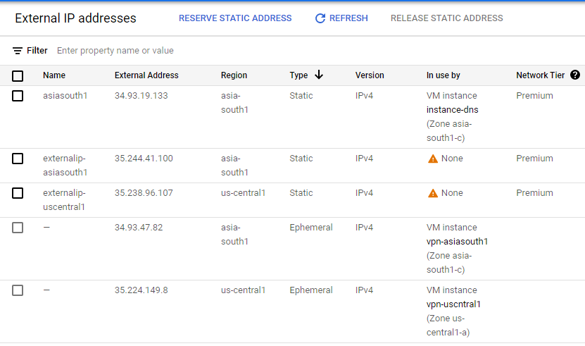

Step 8 : Open Hybrid Connectivity 🡪 VPN connection and create VPN for both networks

- Here the shared key must be same for both networks

- Remote peer IP address is the external IP address of other network

- Remote network IP range is the IP range of other network

***For vpn-asiasouth1 network :***

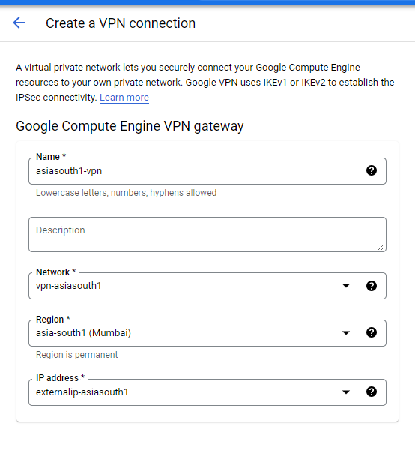

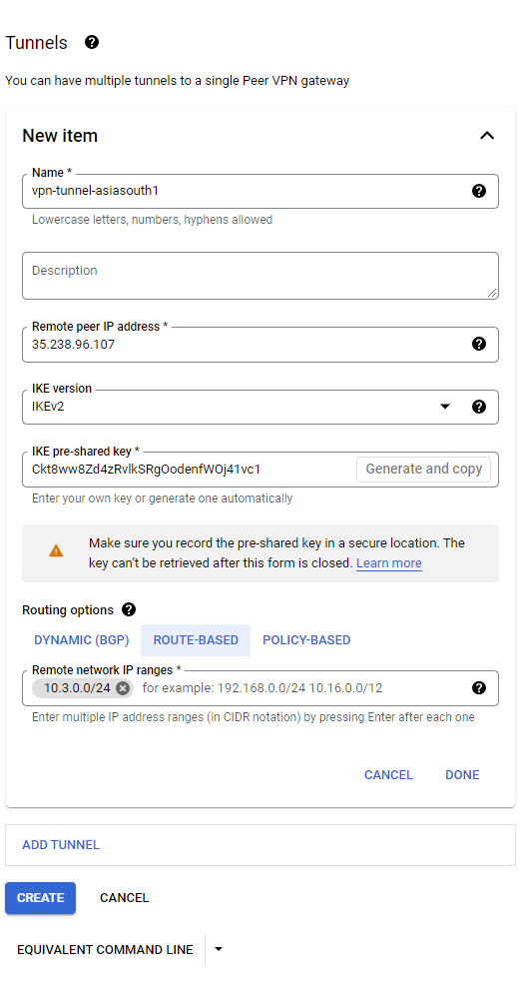

***For vpn-uscentral1 network :***

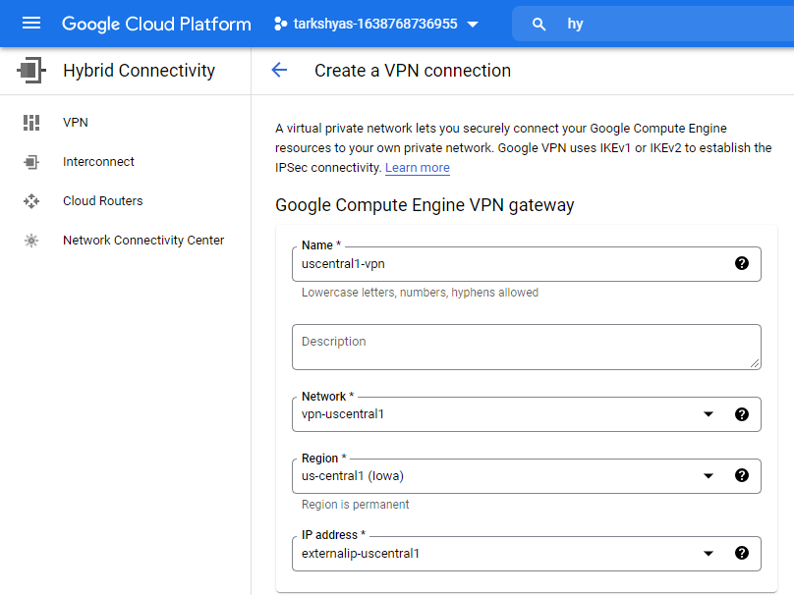

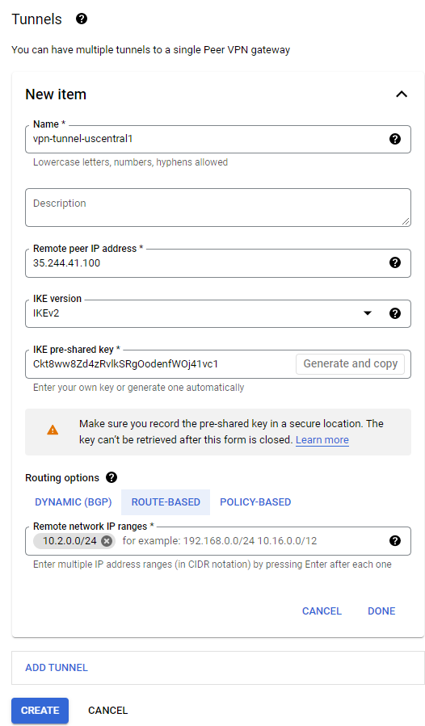

Step 9 : Created VPN connections

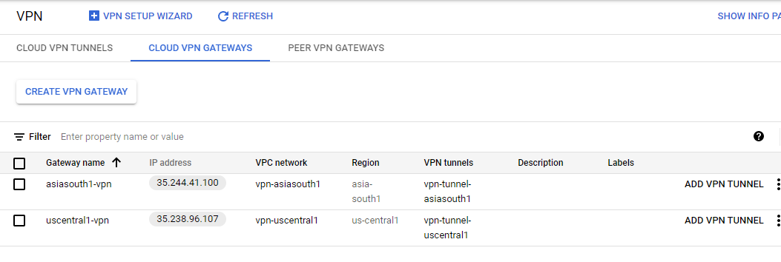

Step 10 : Now try to ping again.

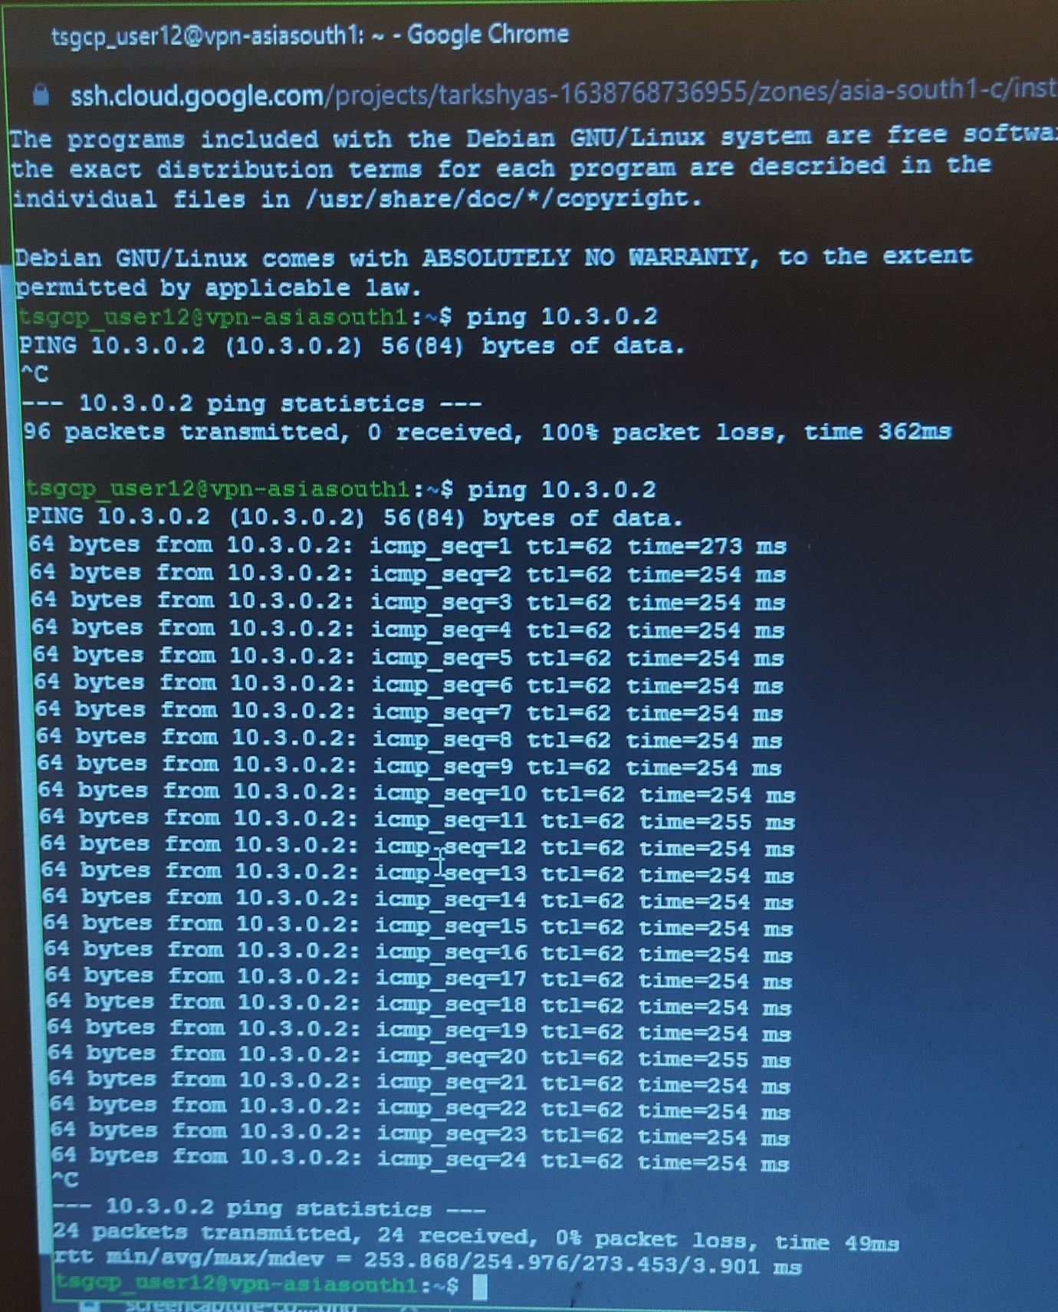

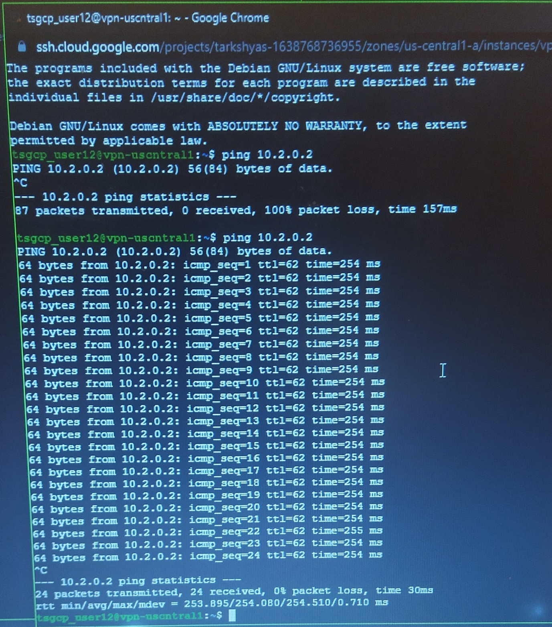

And thus the connection established successfully.

**3) Host a website given below using App Engine standard environment**

<https://github.com/amunategui/rapid-prototyping-app-engine-yelp.git>

Step 1 : Open App Engine and create an application

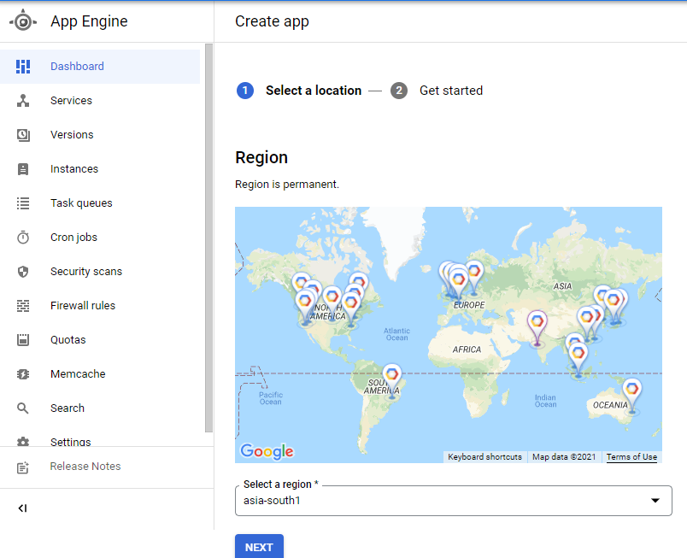

Step 2 : Open cloud shell and install cloud app engine in it

Step 3 : Then clone the required github repository to the shell using git clone command

Step 4 : Go to the path containing all the required files and install requirements.txt

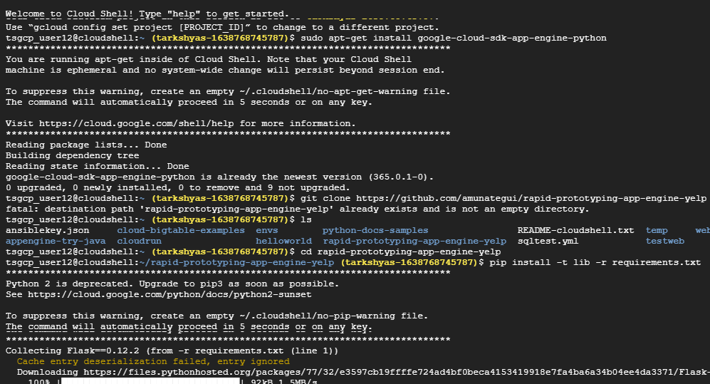

Step 5 : Initiate google cloud by the command gcloud init

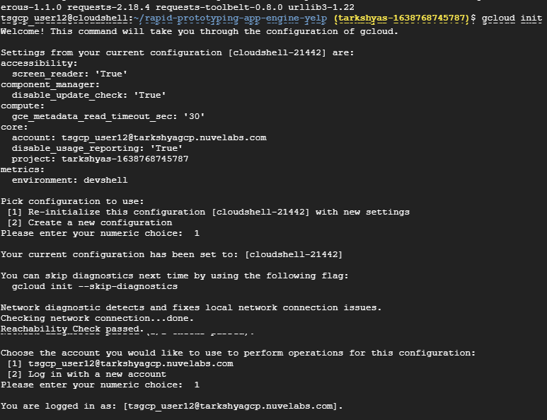

Step 6 : Configure the project and deploy using gcloud app deploy command

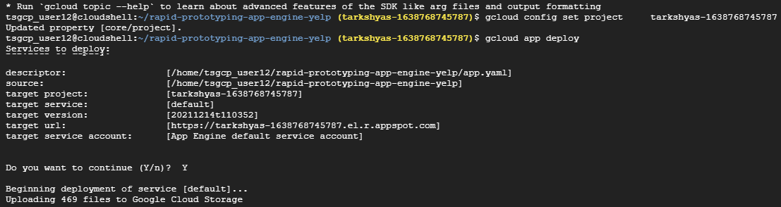

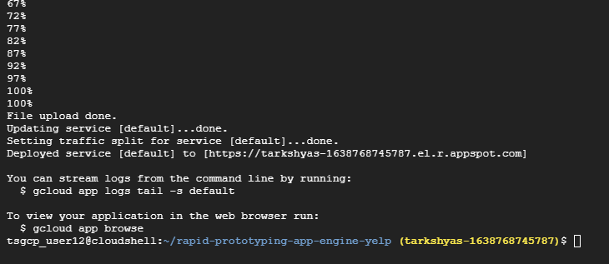

Step 7 : Copy and paste the link generated after deploying. It leads to the particular website created by deploying application using app engine.

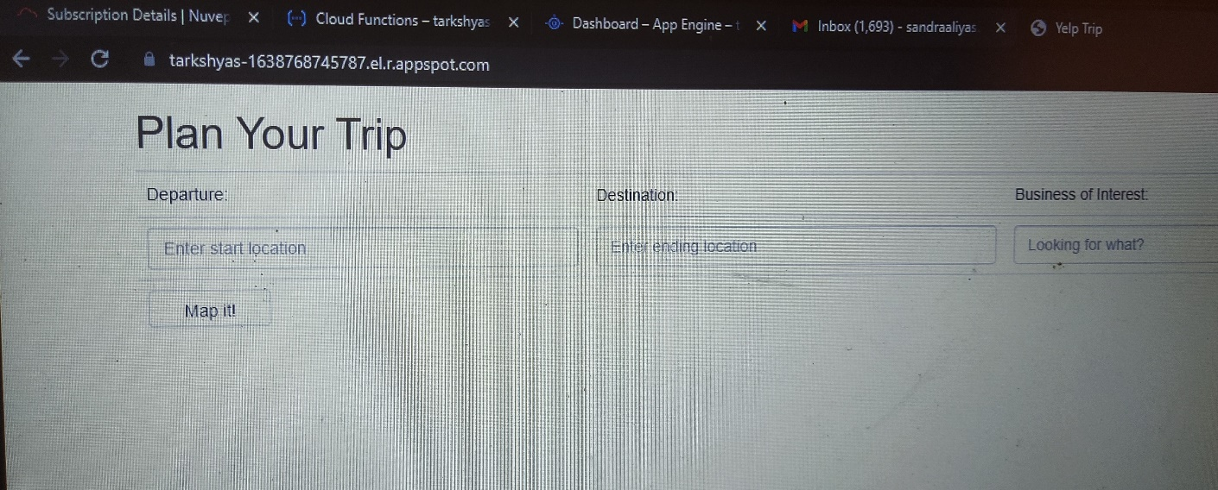

**4) Host a website given below using App Engine flexible environment**

<https://github.com/amunategui/rapid-prototyping-app-engine-yelp.git>

Step 1 : Open App Engine and create an application



Step 2 : Open cloud shell and install cloud app engine in it

Step 3 : Then clone the required github repository to the shell using git clone command

Step 4 : Go to the path containing all the required files and install requirements.txt



Step 5 : Initiate google cloud by the command gcloud init



Step 6 : Configure the project and deploy using gcloud app deploy command





Step 7 : Copy and paste the link generated after deploying. It leads to the particular website created by deploying application using app engine.



**5) Create Cloud Function and deploy it.**

Step 1 : Create a function in Cloud function with http trigger

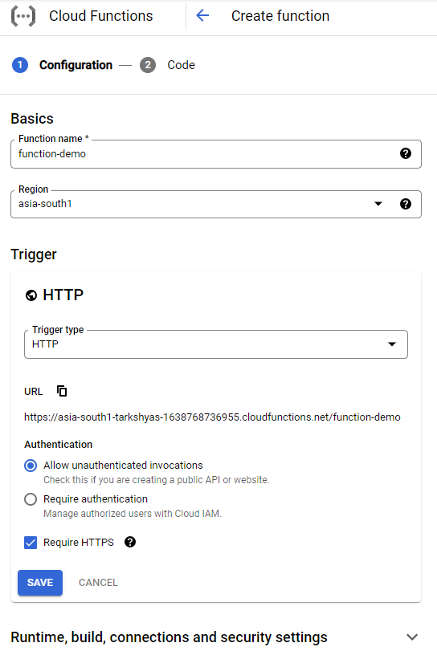

Step 2 : Set runtime to python and deploy the code

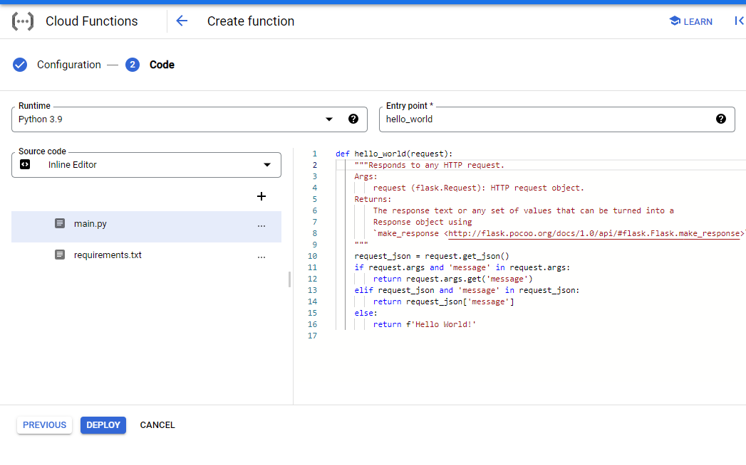

Step 3 : Thus the function is deployed and now test the function

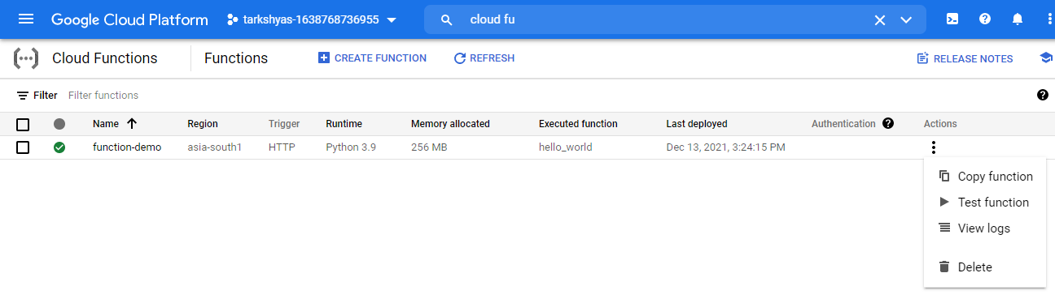

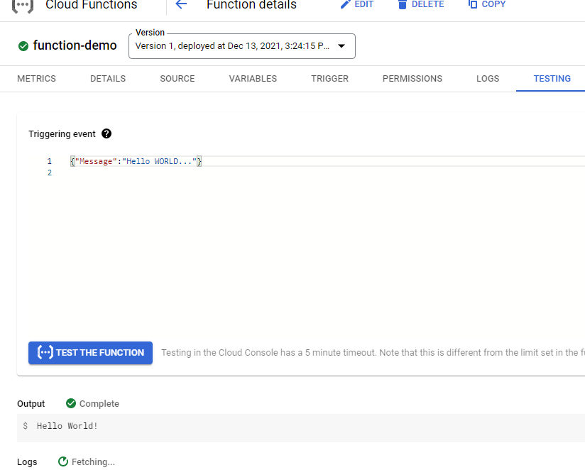

Step 4 : Now go to the trigger and we can see an URL created which leads to the result of deployed function ie, Hello World!

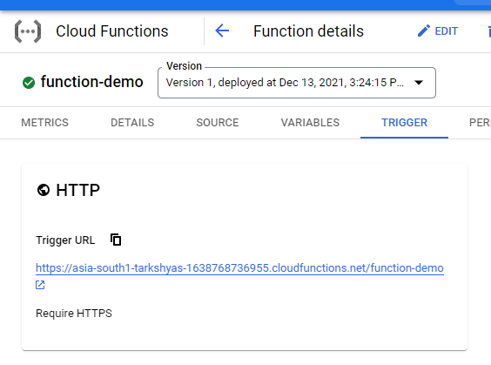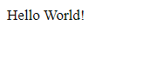

**6) Create a service and deploy using Cloud Run**

//******************** **Create and deploy Kubernetes Engine** ********************//

Step 1 : Find a github repository for hosting the website : https://github.com/learning-zone/website-templates



Step 2 : Open the cloud shell and make a directory ‘temp’.

Step 3 : Inside that directory clone the github site using git clone command and then go to the path of github repository which contains the required files.

Step 4 : Create a container using docker run command and view the running containers by using docker ps : docker run -d -p 8080:80 nginx:latest



Step 5 : Copy all the files insides github repository to the container by using docker cp command : docker cp about.html fe5081bc7dd6:/usr/share/nginx/html/



Step 6 : Then commit docker inorder to allow users to take the running container and save its current state as an image : docker commit fe5081bc7dd6 testsite:version1

Step 7 : Share those images to the Docker Hub registry using docker push :

docker tag testsite:version1 us.gcr.io/ tarkshyas-1638768745787/testsite:version1

docker push us.gcr.io/ tarkshyas-1638768745787/testsite:version1



Step 8 : Go to the container registry and view the image created



Step 9 : Open Workloads in Kubernetes Engine and deploy the application





Step 10 : Expose the deployed application



Step 11 : After deployment and expose





Step 12 : By clicking on external endpoints we get the required website



//************************** **Cloud Run** *******************************//

Step 13 : Open cloud run and create a service with container image url created in container registry

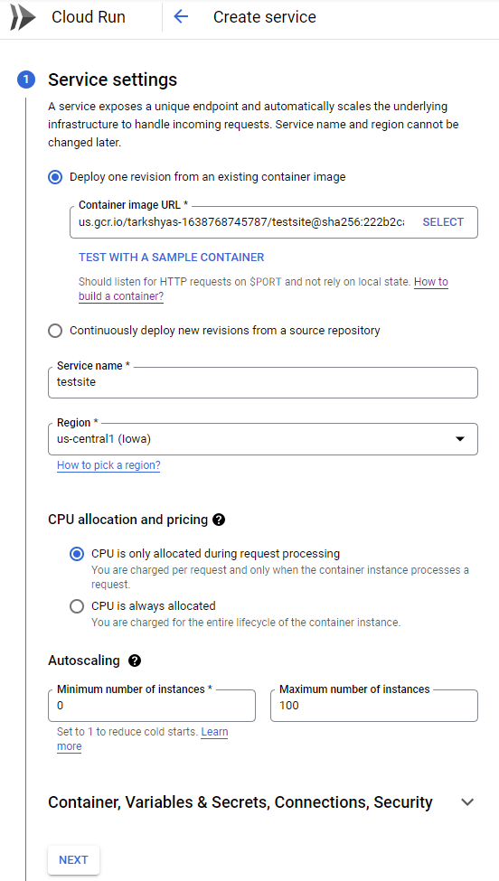

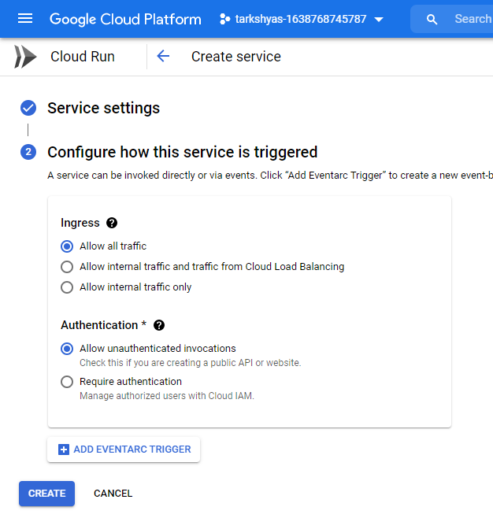

Step 14 : Created service in cloud run which generates a URL leading to the particular site

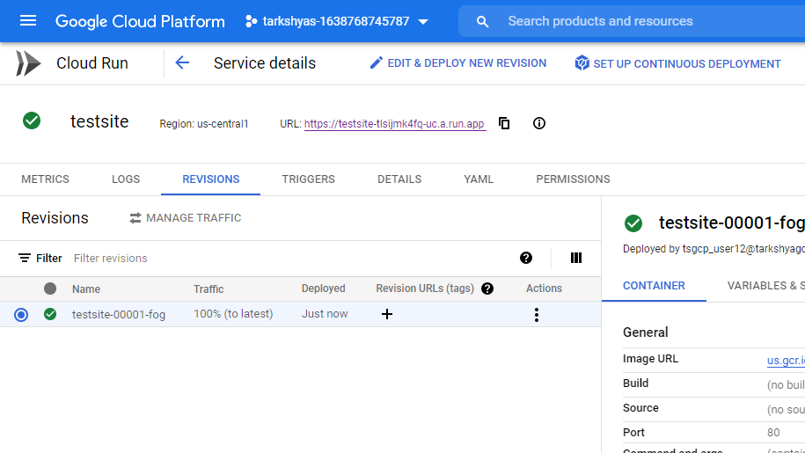

Step 15 : URL redirects to :-



**7) How VPC peering helps to communicate between 2 VM instance in different networks ?**

Step 1 : Create a vpc network ‘network-a’ with two subnets.

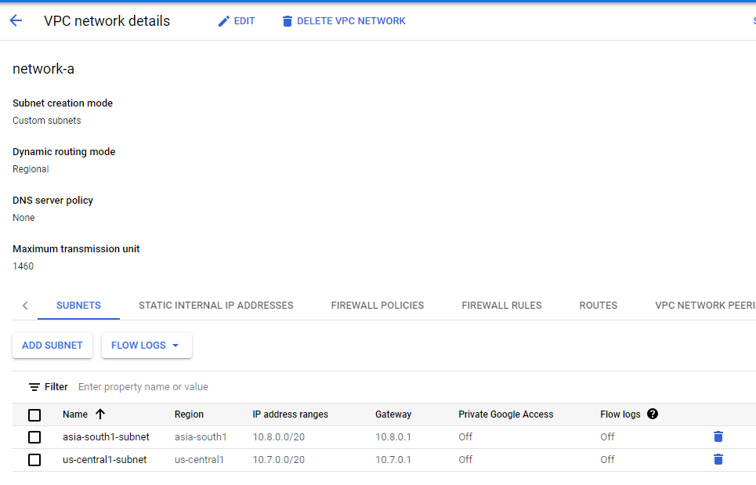

Step 2 : Assign firewall rules to the created network-a

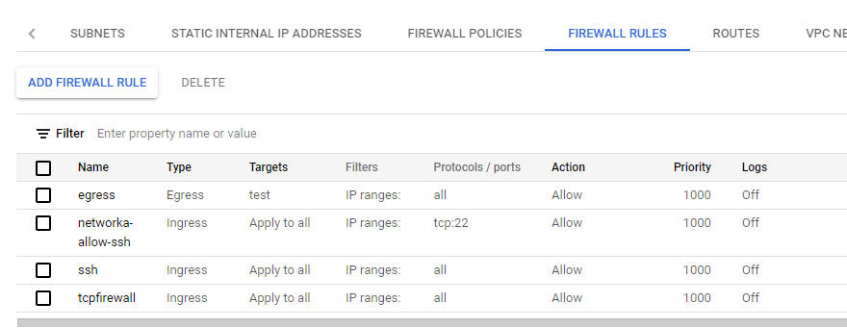

Step 3 : Create VM instance for default network with Networking field as follows

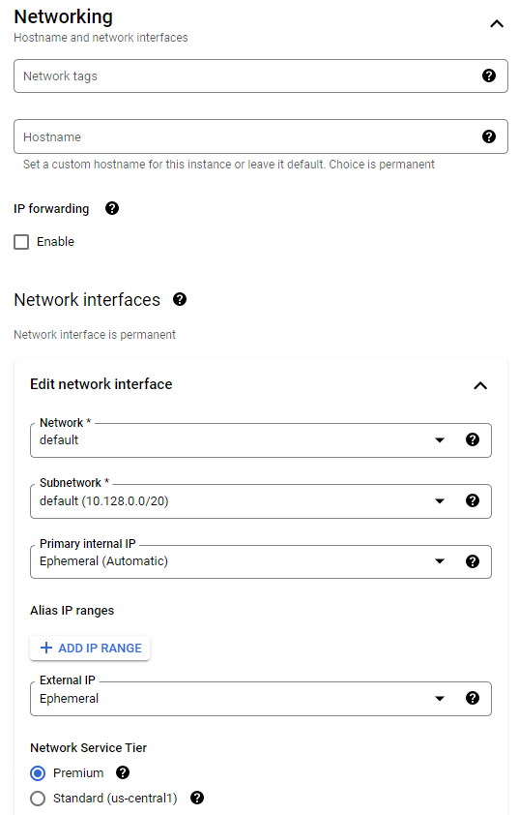

Step 4 : Create VM instance for network-a with Networking field as follows

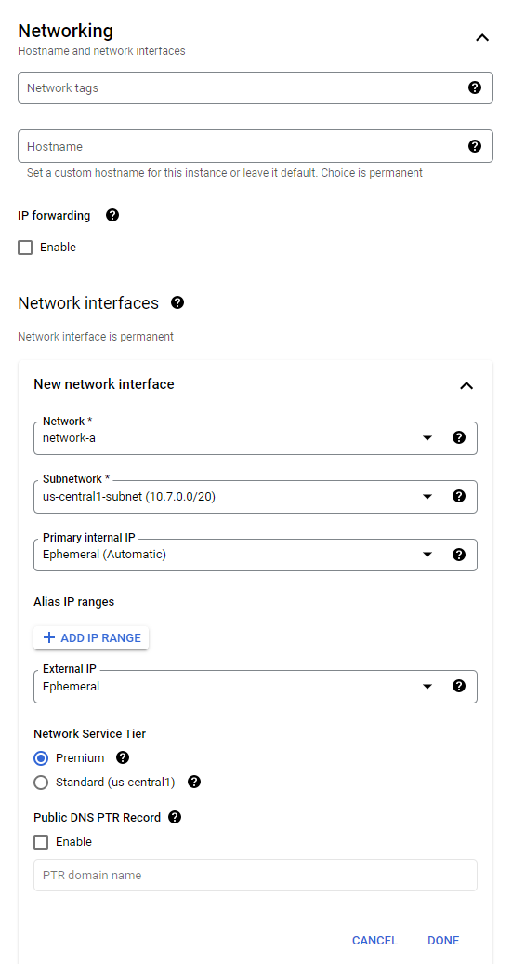

Step 5 : VM instances created for both default network and network-a

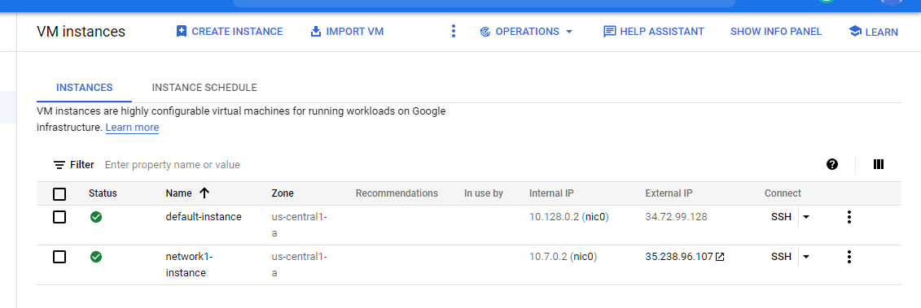

Step 6 : Try to connect these two networks by clicking on SSH and ping.

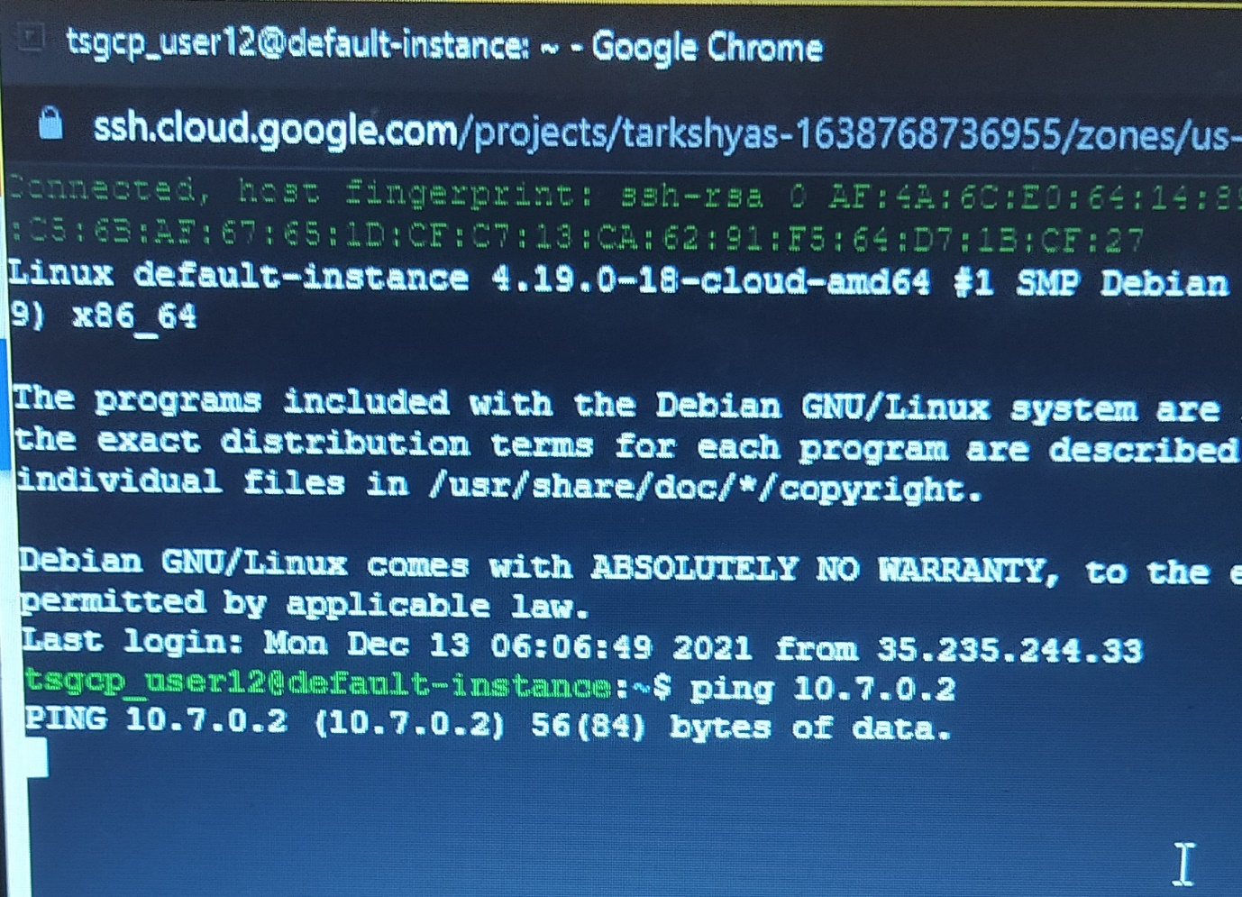

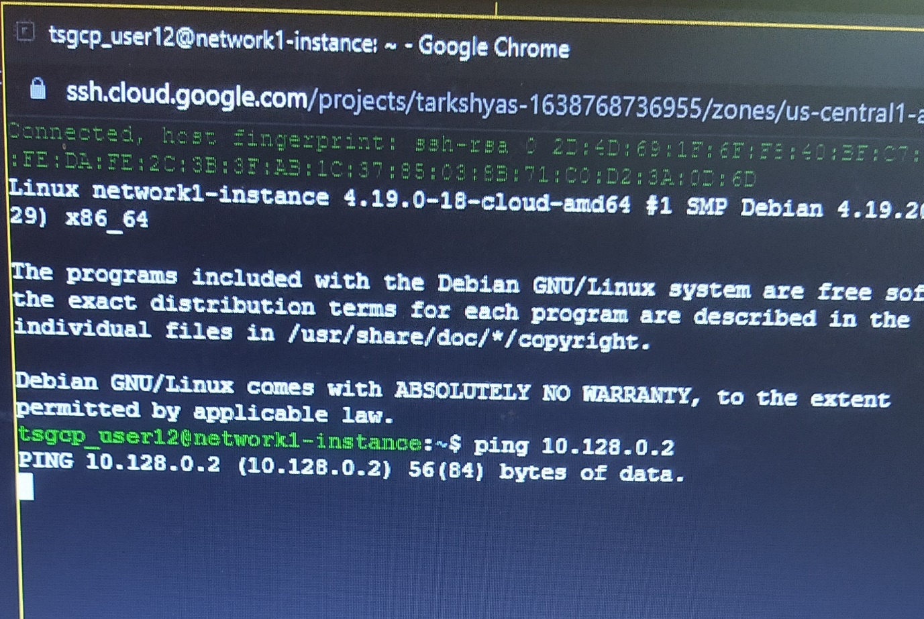

Ping doesn’t happens and so the connection fails. Inorder to establish connection, we need to create VPC peering.

Step 7 : Create VPC peering connection between default network and network-a as follows

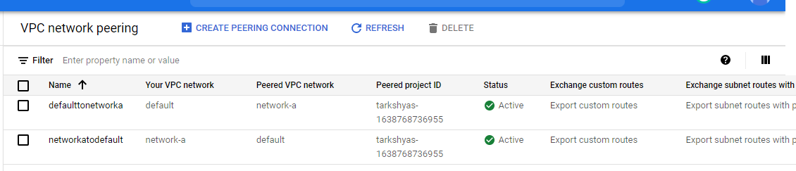

Step 8 : Now try to ping both networks.

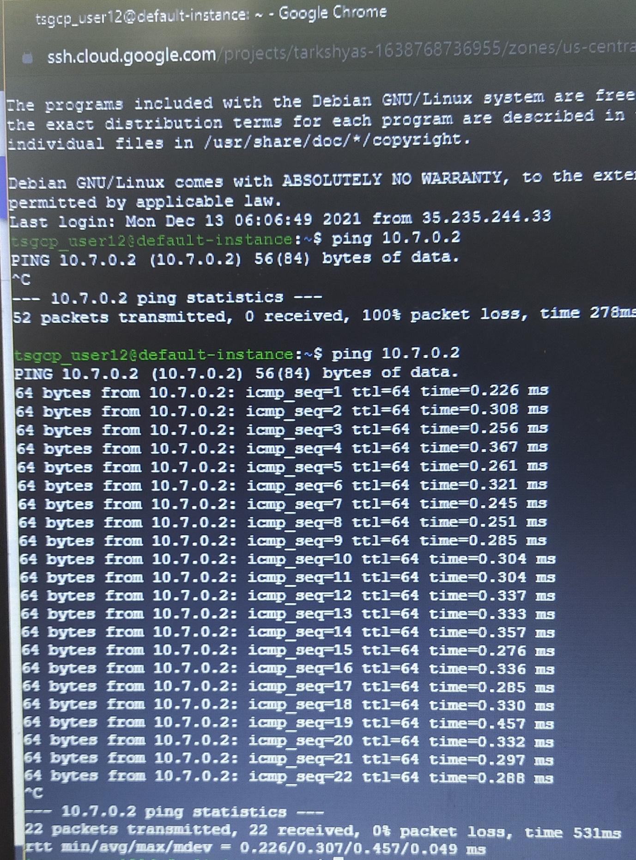

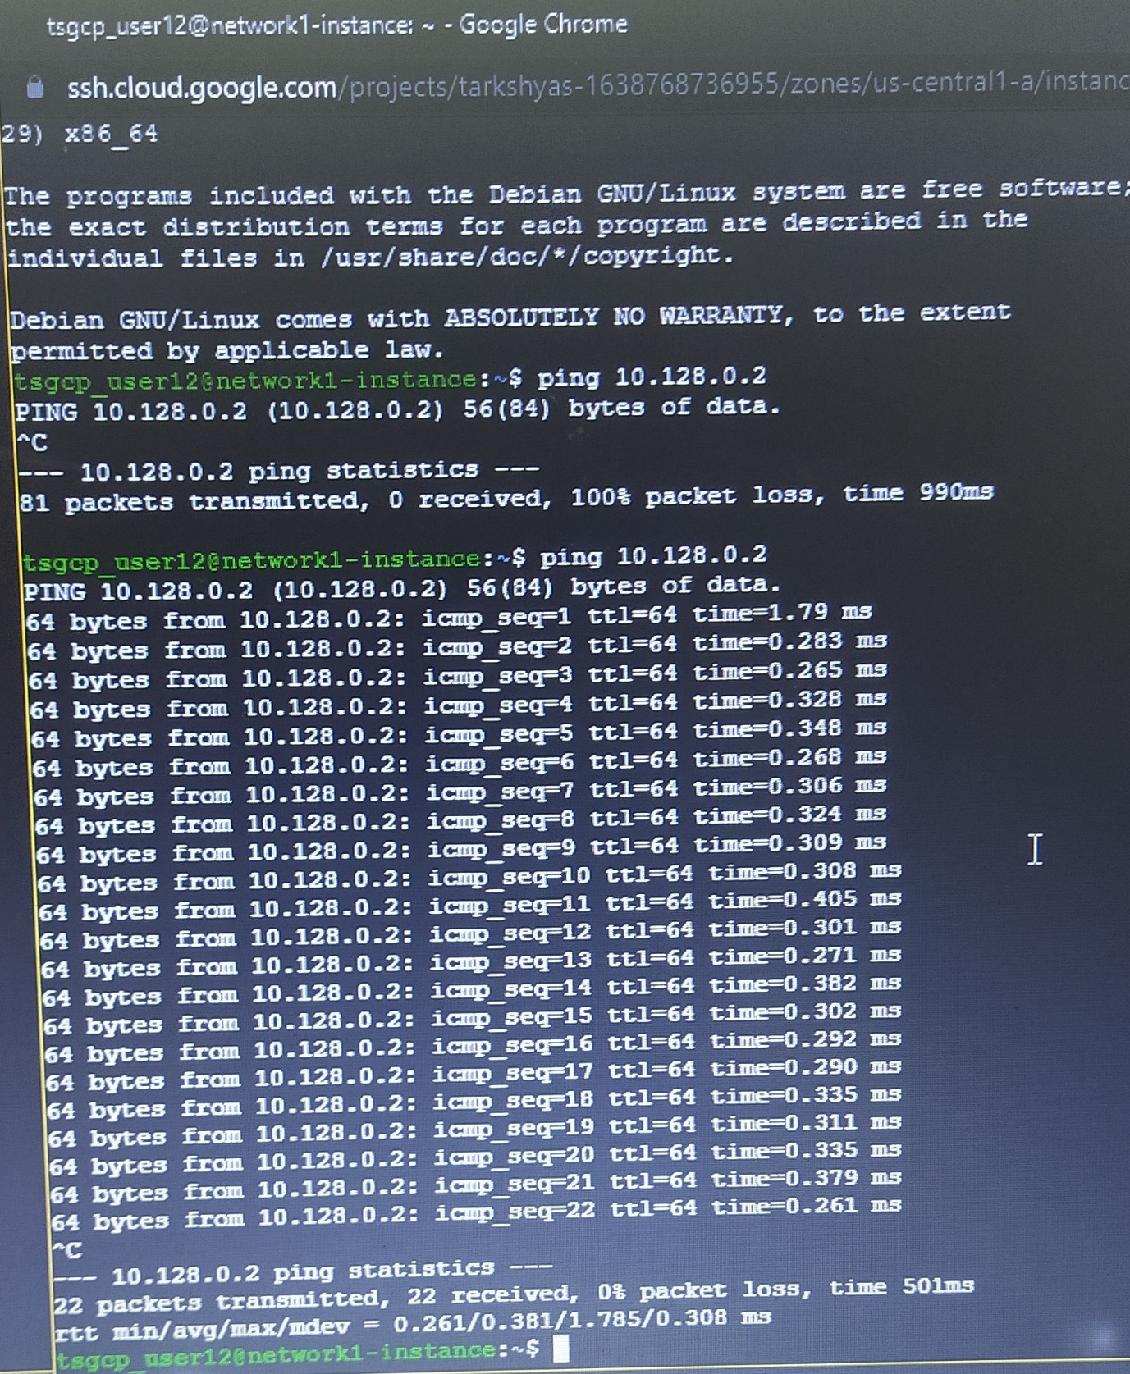

Connection established successfully.

**8) Create a domain and host a website using Cloud DNS**

//******************** **Create and deploy Kubernetes Engine** ********************//

Step 1 : Find a github repository for hosting the website : https://github.com/learning-zone/website-templates



Step 2 : Open the cloud shell and make a directory ‘temp’.

Step 3 : Inside that directory clone the github site using git clone command and then go to the path of github repository which contains the required files.

Step 4 : Create a container using docker run command and view the running containers by using docker ps : docker run -d -p 8080:80 nginx:latest



Step 5 : Copy all the files insides github repository to the container by using docker cp command : docker cp about.html fe5081bc7dd6:/usr/share/nginx/html/



Step 6 : Then commit docker inorder to allow users to take the running container and save its current state as an image : docker commit fe5081bc7dd6 testsite:version1

Step 7 : Share those images to the Docker Hub registry using docker push :

docker tag testsite:version1 us.gcr.io/ tarkshyas-1638768745787/testsite:version1

docker push us.gcr.io/ tarkshyas-1638768745787/testsite:version1



Step 8 : Go to the container registry and view the image created



Step 9 : Open Workloads in Kubernetes Engine and deploy the application





Step 10 : Expose the deployed application



Step 11 : After deployment and expose





Step 12 : By clicking on external endpoints we get the required website



//************************** **Cloud DNS** *******************************//

Step 13 : Create a domain in freenom

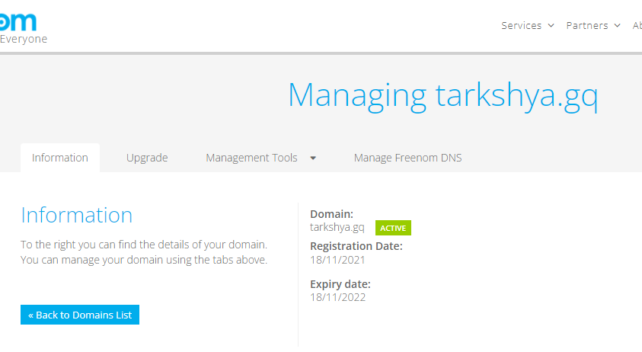

Step 14 : Create zone in Cloud DNS

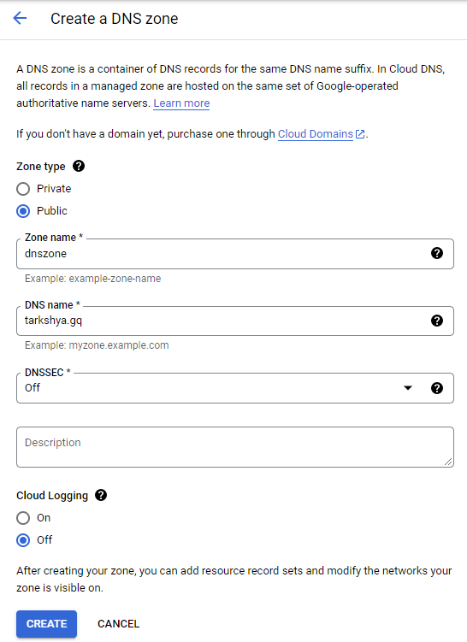

Step 15 : Copy the nameservers of created zone and paste it in nameserver of created domain

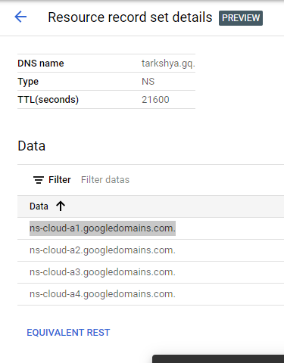

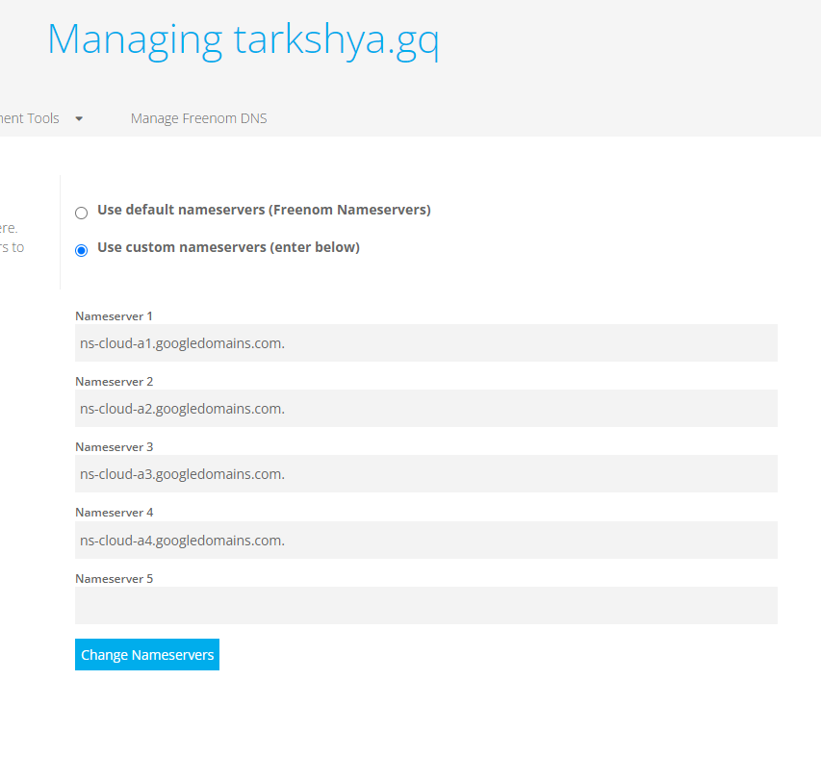

Step 16 : Create a record set in the zone with resourse record type as A and assign the IPv4 address as the external endpoints created in Kubernetes engine

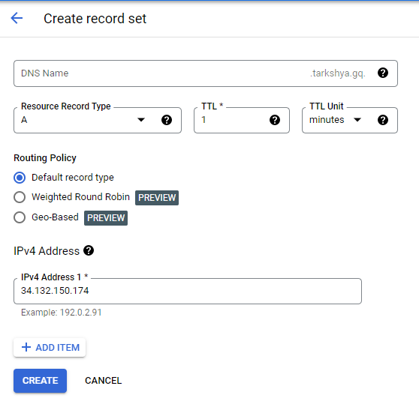

Step 17 : Browse tarkshya.gq in google and we can see the respective site



Step 18 : Create a record set in the zone with resourse record type as CNAME and assign the IPv4 address as the external endpoints created in Kubernetes engine

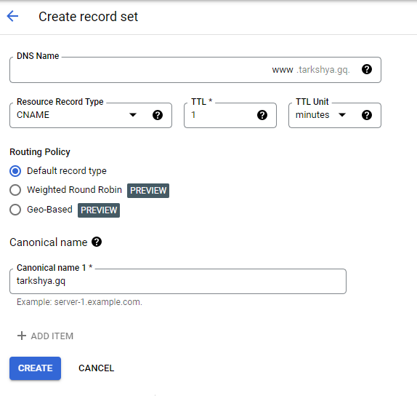

Step 19 : Browse www.tarkshya.gq in google and we can see the respective site

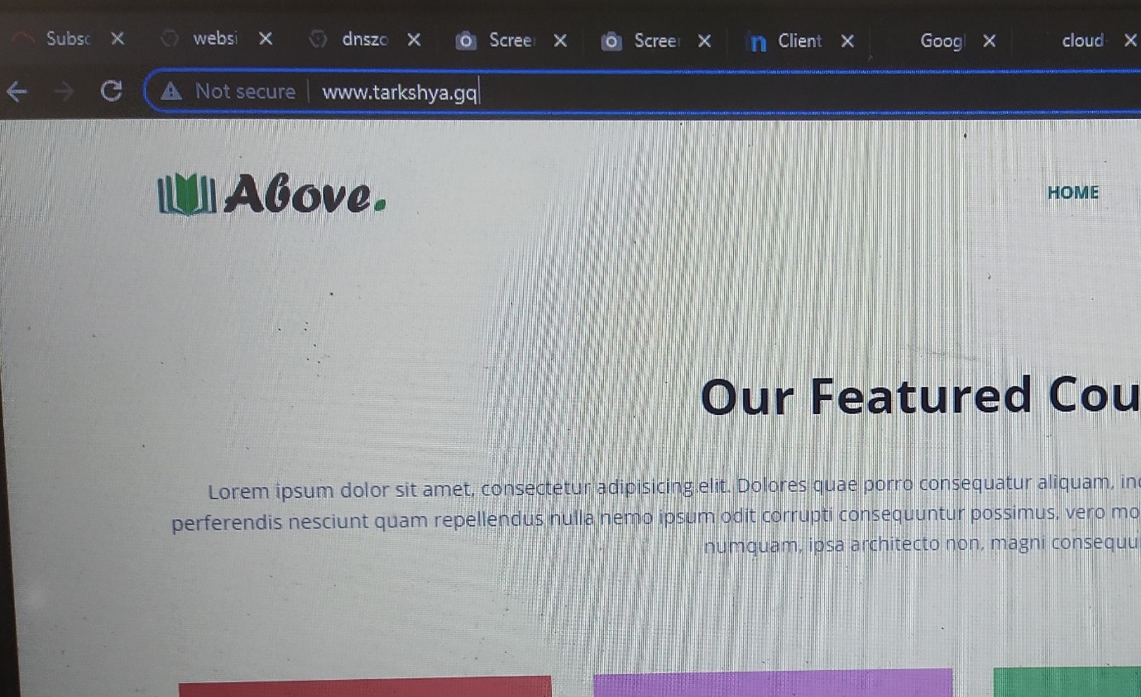

**9) How to visualise the traffic in instance group using Load Balancing ?**

Step 1 : Create an instance template with following details

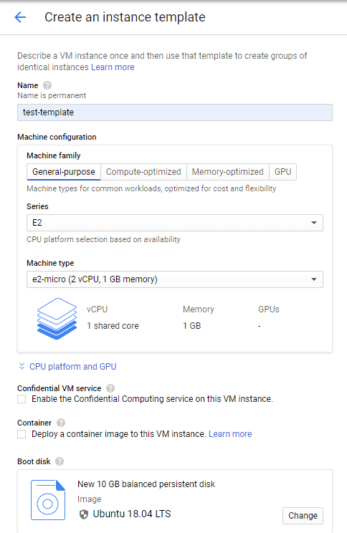

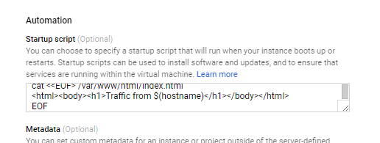

Startup script :

#! /bin/bash

apt-get update

apt-get install -y apache2

cat <<EOF > /var/www/html/index.html

<html><body><h1>Traffic from $(hostname)</h1></body></html>

EOF

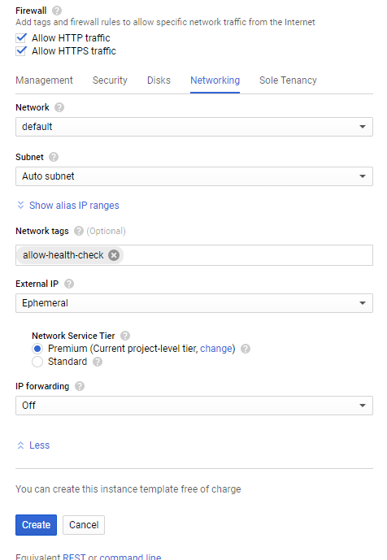

Step 2 : Create a new managed instance group with 2 instances

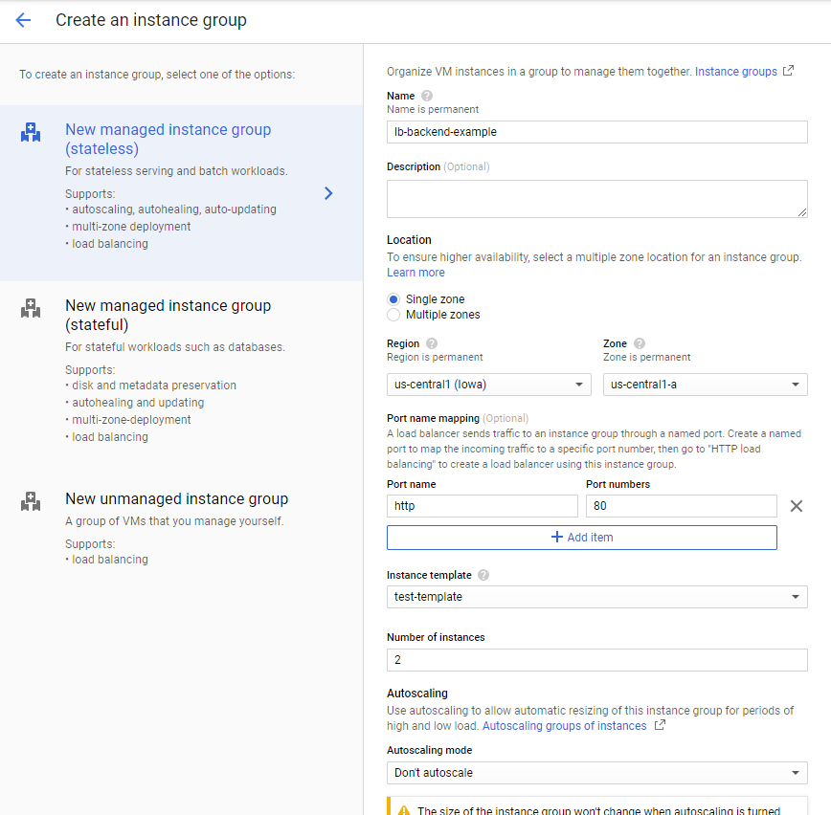

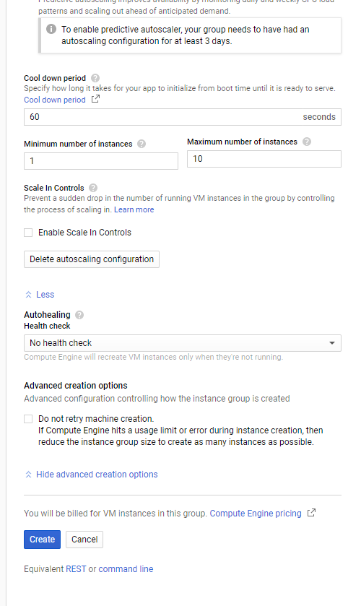

Create health check for instance group inorder to detect and automatically remove unhealthy VM instances.

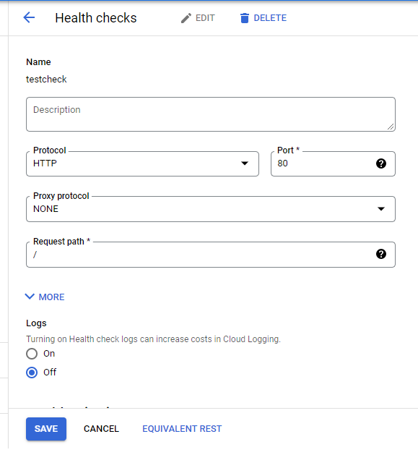

Step 3 : Created instance group

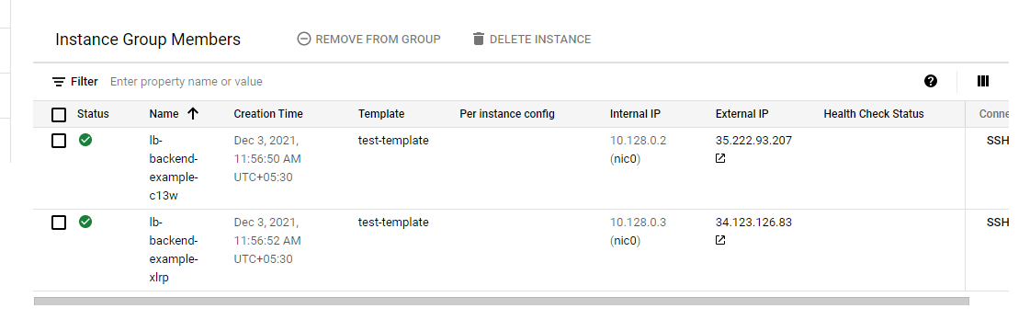

Step 4 : Set firewall rules for health-check

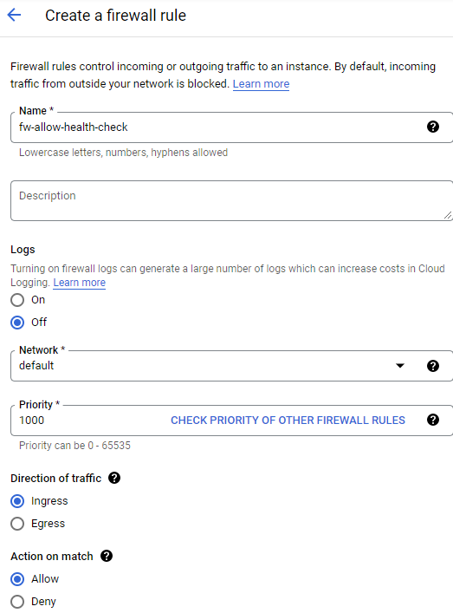

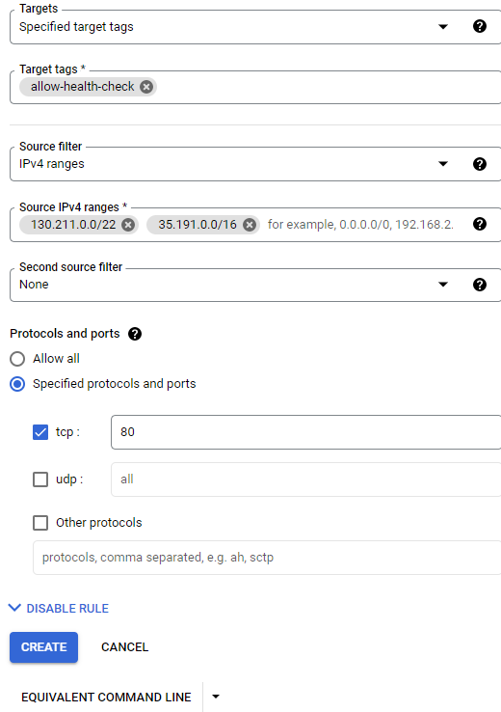

Step 5 : Reserve an external ip address

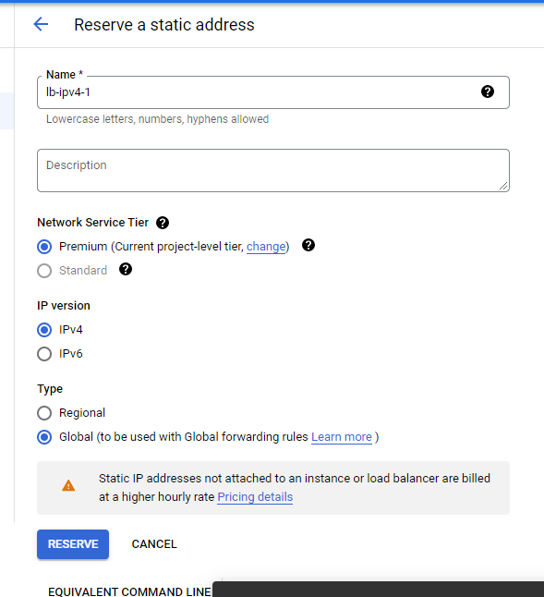

Step 6 : Now create a http load balancer

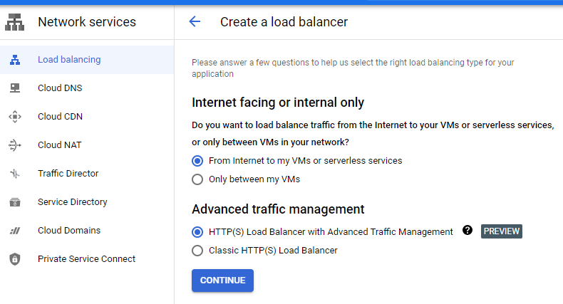

Step 7 : Fill up the Backend configuration as

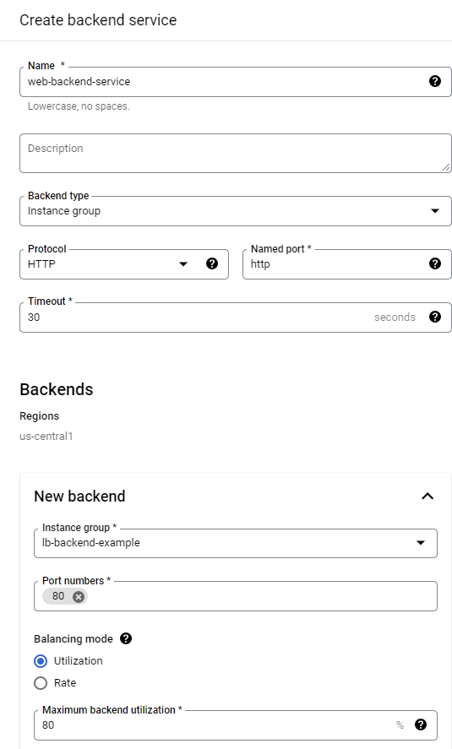

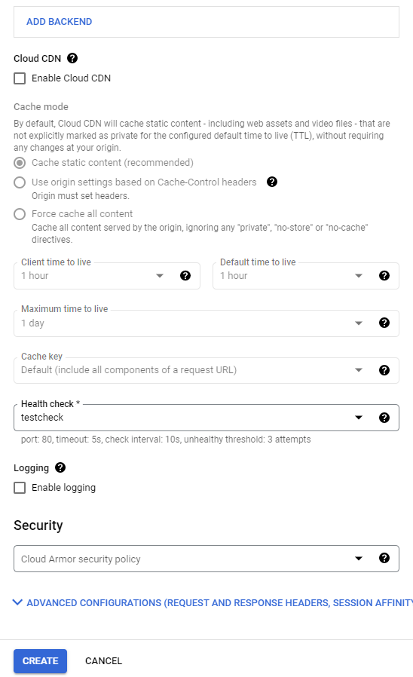

Step 8 : Fill up the front end configuration as

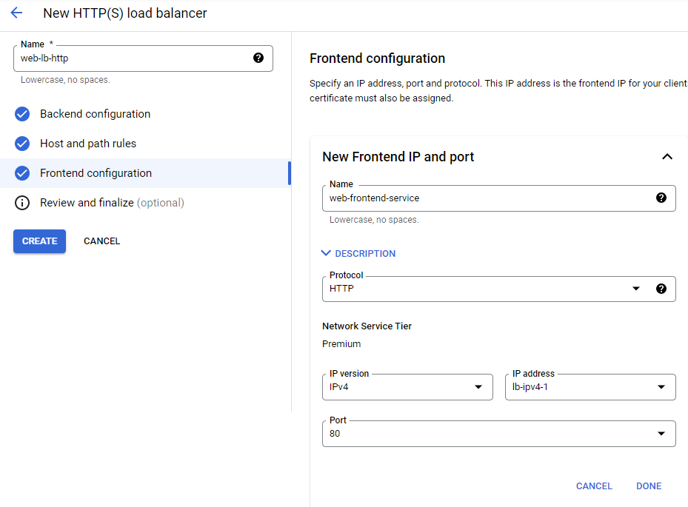

Step 9 : Review and finalize

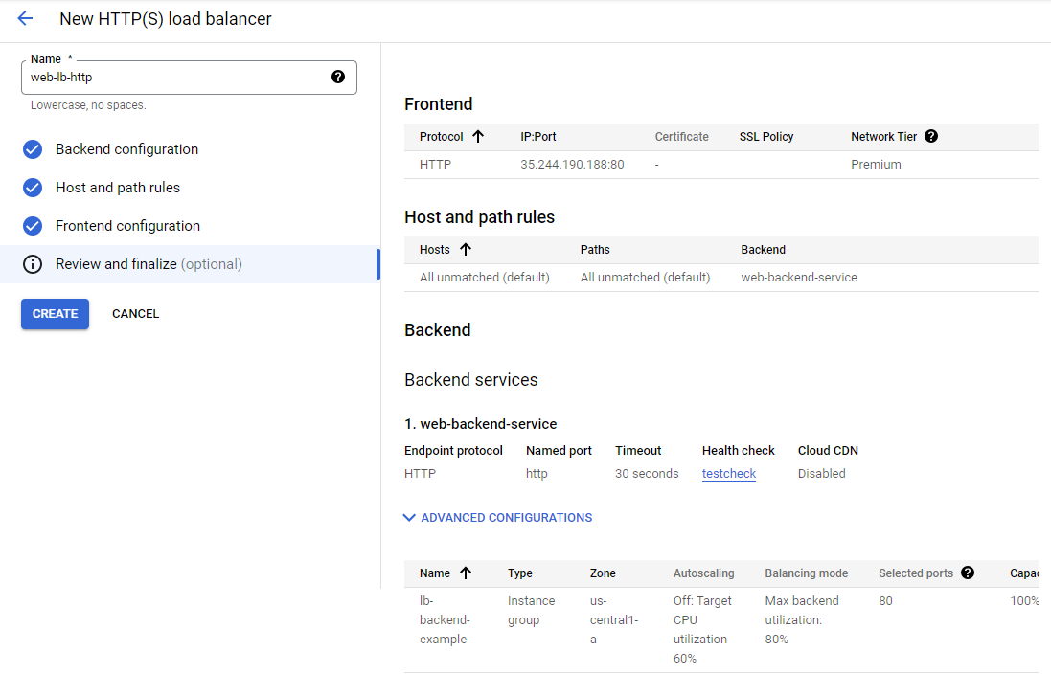

Step 10 : Load balancer created

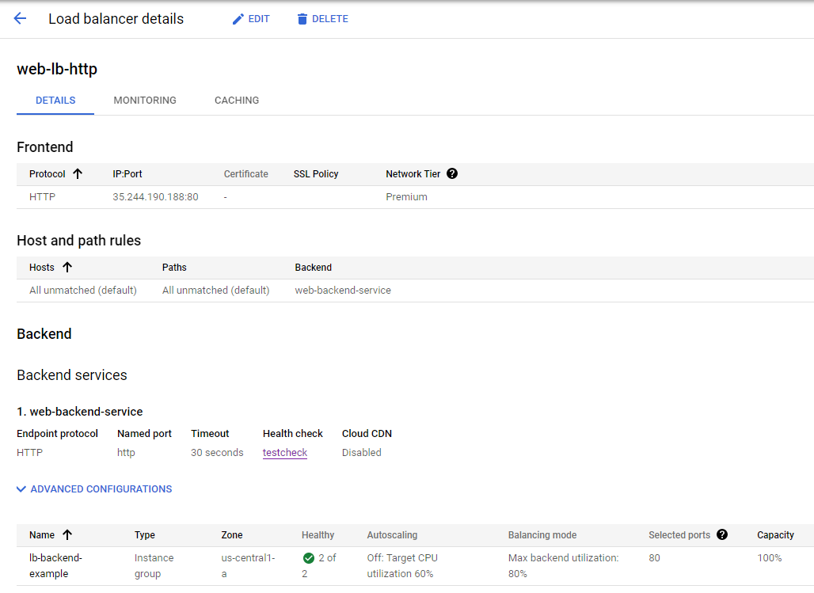

Step 11 : By browsing the IP:Port generated we get the traffic from instance group. Refreshing the site we can see theat traffic changes between two instances.

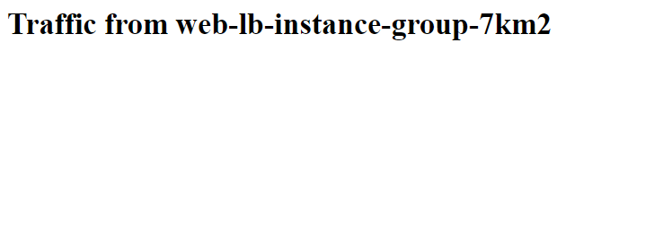

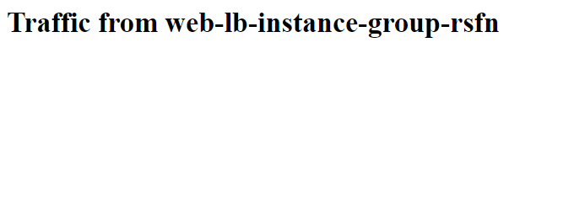

**10) How to host a website using Kubernets Engine?**

Step 1 : Find a github repository for hosting the website : https://github.com/learning-zone/website-templates



Step 2 : Open the cloud shell and make a directory ‘temp’.

Step 3 : Inside that directory clone the github site using git clone command and then go to the path of github repository which contains the required files.

Step 4 : Create a container using docker run command and view the running containers by using docker ps : docker run -d -p 8080:80 nginx:latest

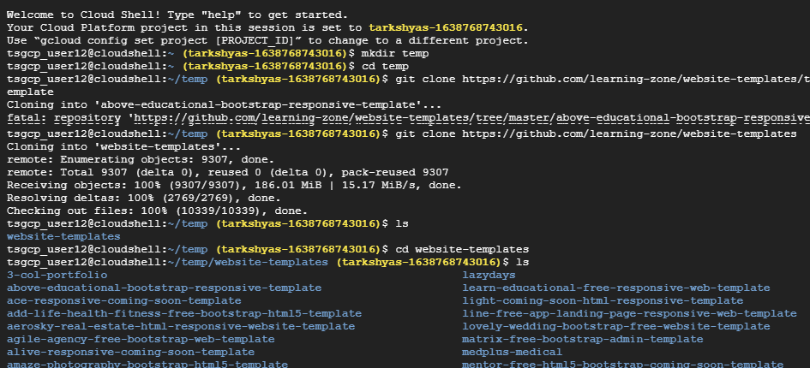

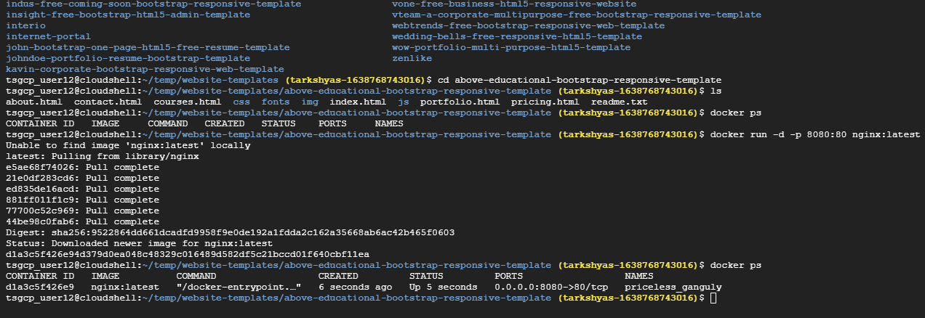

Step 5 : Copy all the files insides github repository to the container by using docker cp command : docker cp about.html d1a3c5f426e9:/usr/share/nginx/html/

Step 6 : Then commit docker inorder to allow users to take the running container and save its current state as an image : docker commit d1a3c5f426e9 testsite:version1

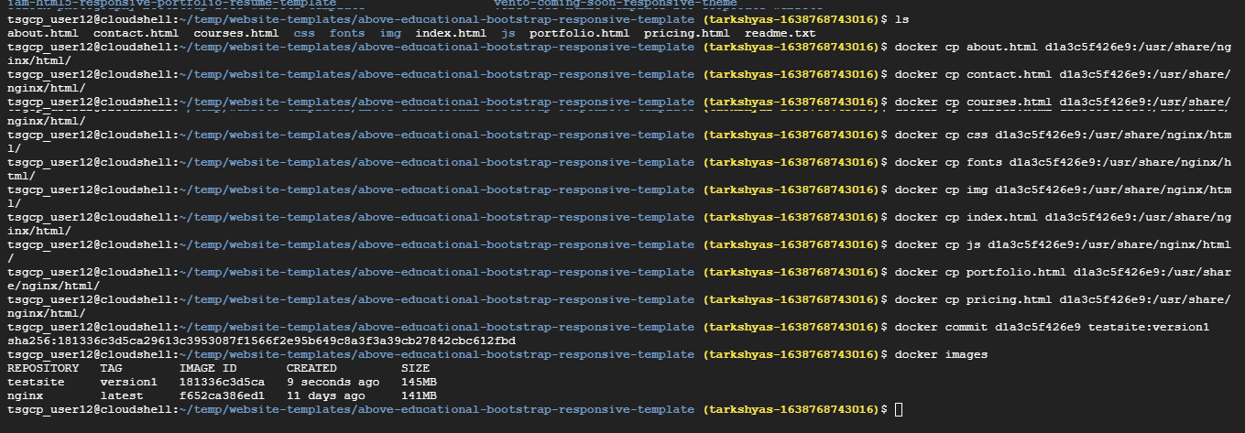

Step 7 : Share those images to the Docker Hub registry using docker push :

docker tag testsite:version1 us.gcr.io/tarkshyas-1638768743016/testsite:version1

docker push us.gcr.io/tarkshyas-1638768743016/testsite:version1

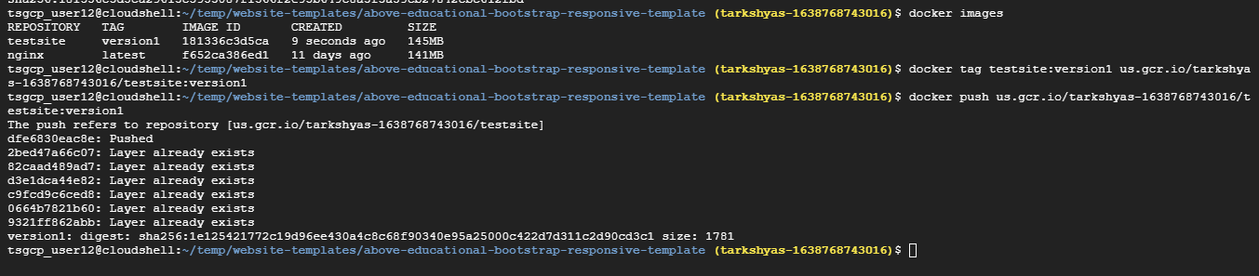

Step 8 : Go to th container registry and view the image created

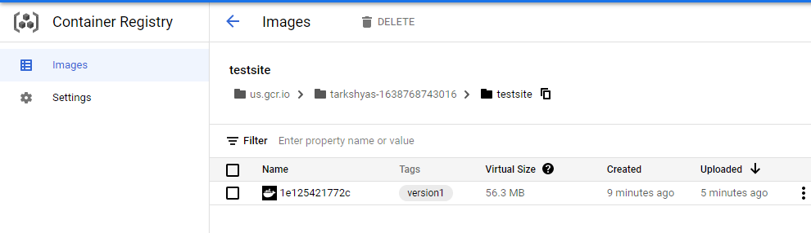

Step 9 : Open Workloads in Kubernetes Engine and deploy the application

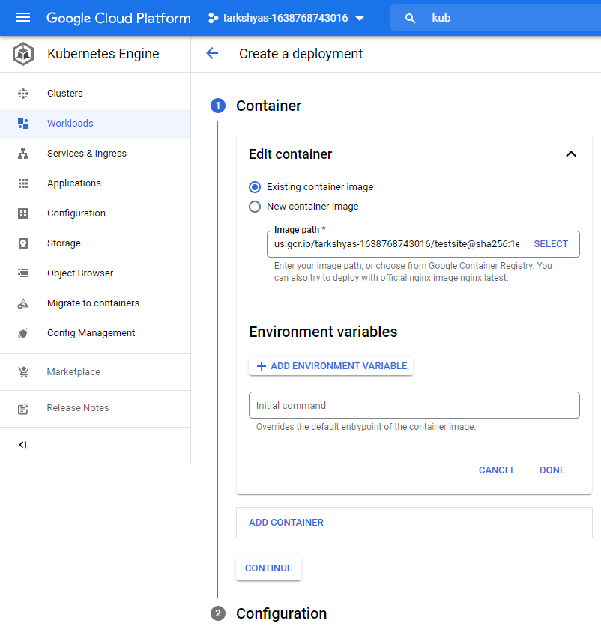

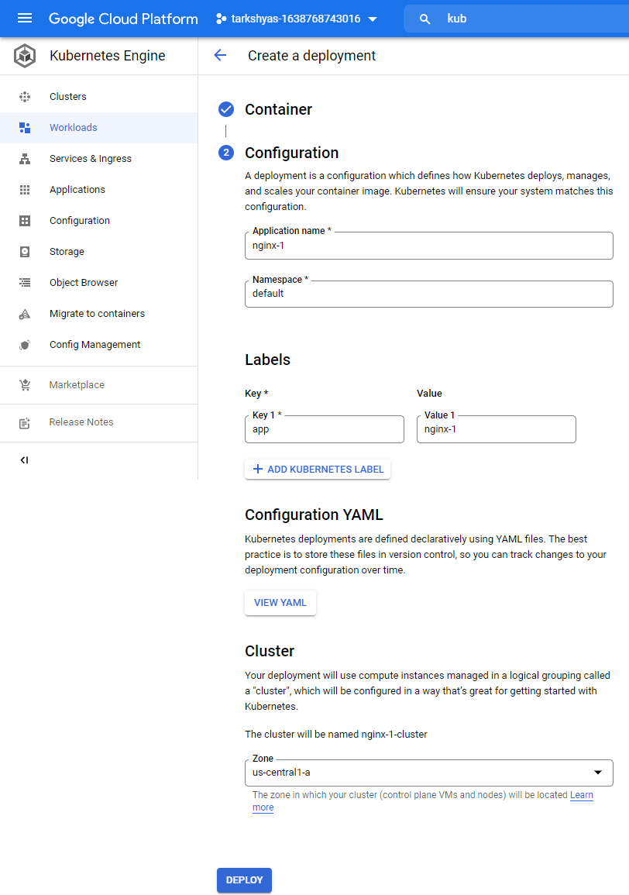

Step 10 : After deploying

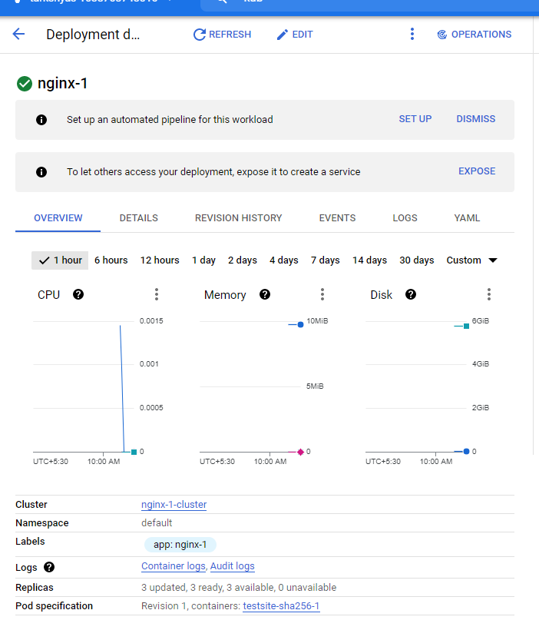

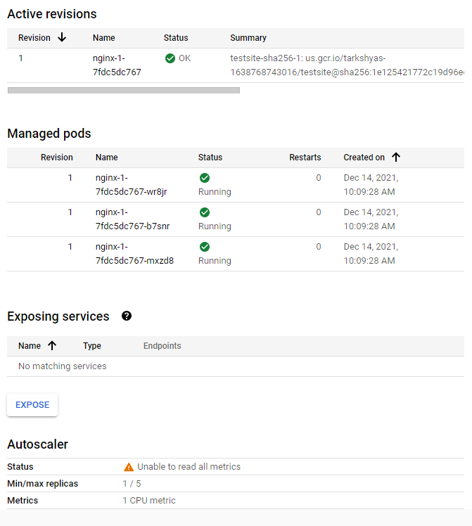

Step 11 : Expose the deployed application

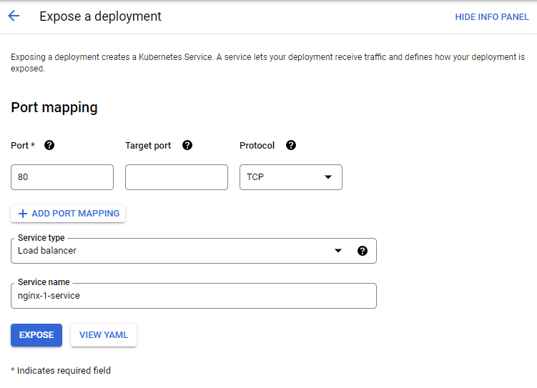

Step 12 : Now by clicking on external endpoints , it will redirects to the required site.

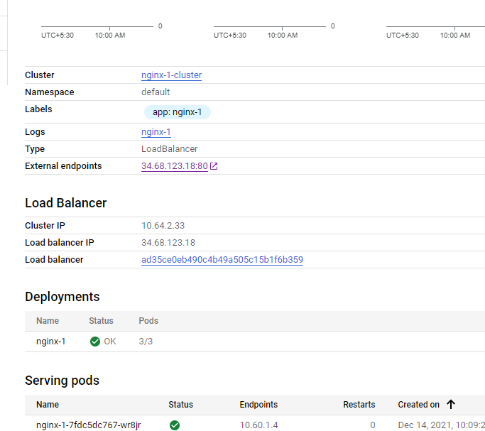



**11.a) Create a VM instance using terraform**

Inorder to use terraform first we have to

- Install Cloud SDK

- Install terraform

- Install VS Studio

- Install terraform inside VS

Step 1 : Create Service account with role as project owner and generate json key for that account.

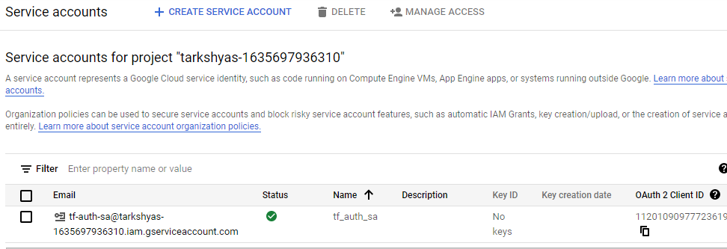

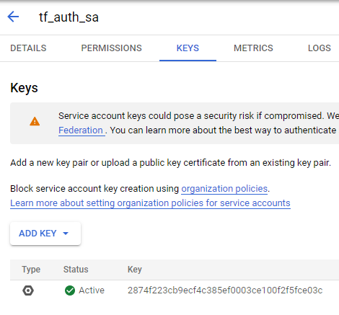

Step 2 : Open VS studio and create files such as provider.tf and vm.tf

Codes inside this files are attached with this document.

Step 3 : Keep the installed terraform , service account key , provider.tf and vm.tf in a same folder

Step 4 : Open cloud sdk and go to the path containing all these files

Step 5 : Now initiate gcloud inside sdk using command ‘init gcloud’

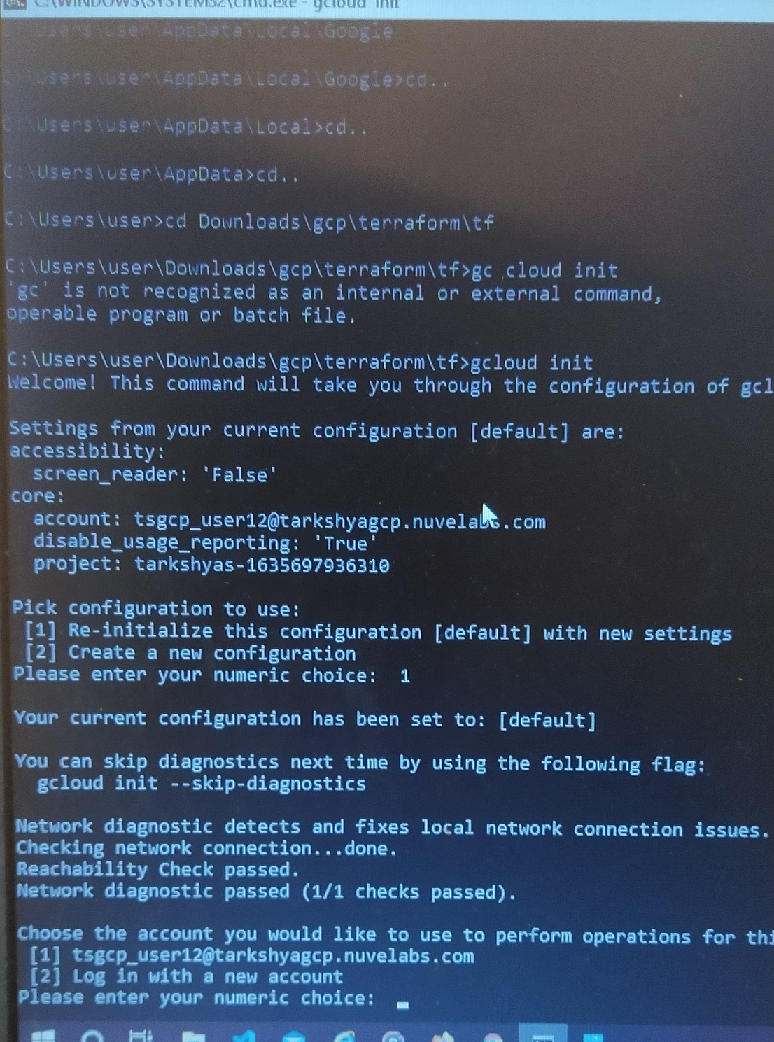

Step 6 : Use ‘terraform init’ command to initialize a working directory containing Terraform configuration files.

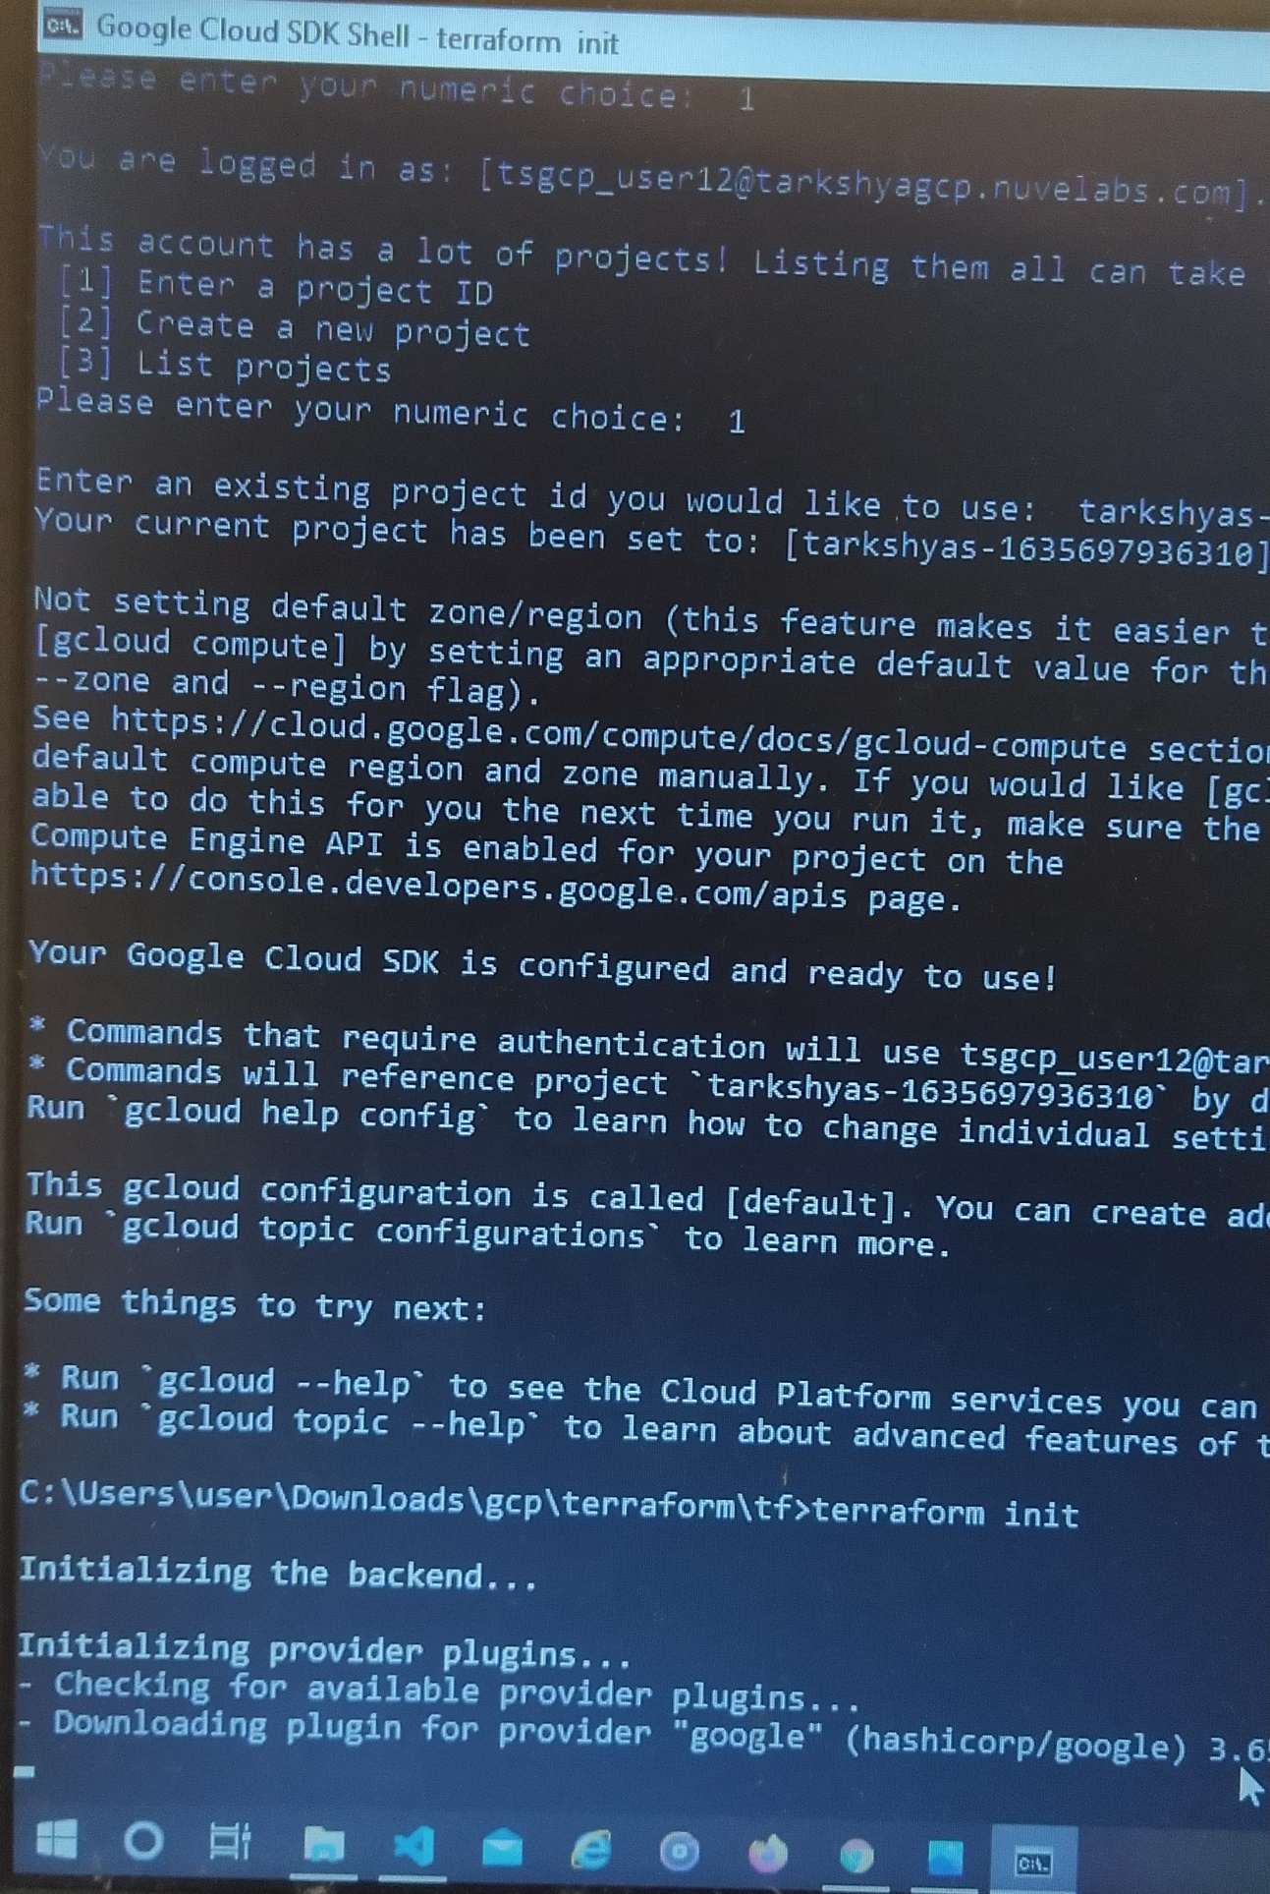

Step 7 : Use ‘terraform plan’ to evaluate a terraform configuration to determine the desired state of all the resources it declares, then compares that desired state to the real infrastructure objects being managed with the current working directory and workspace.

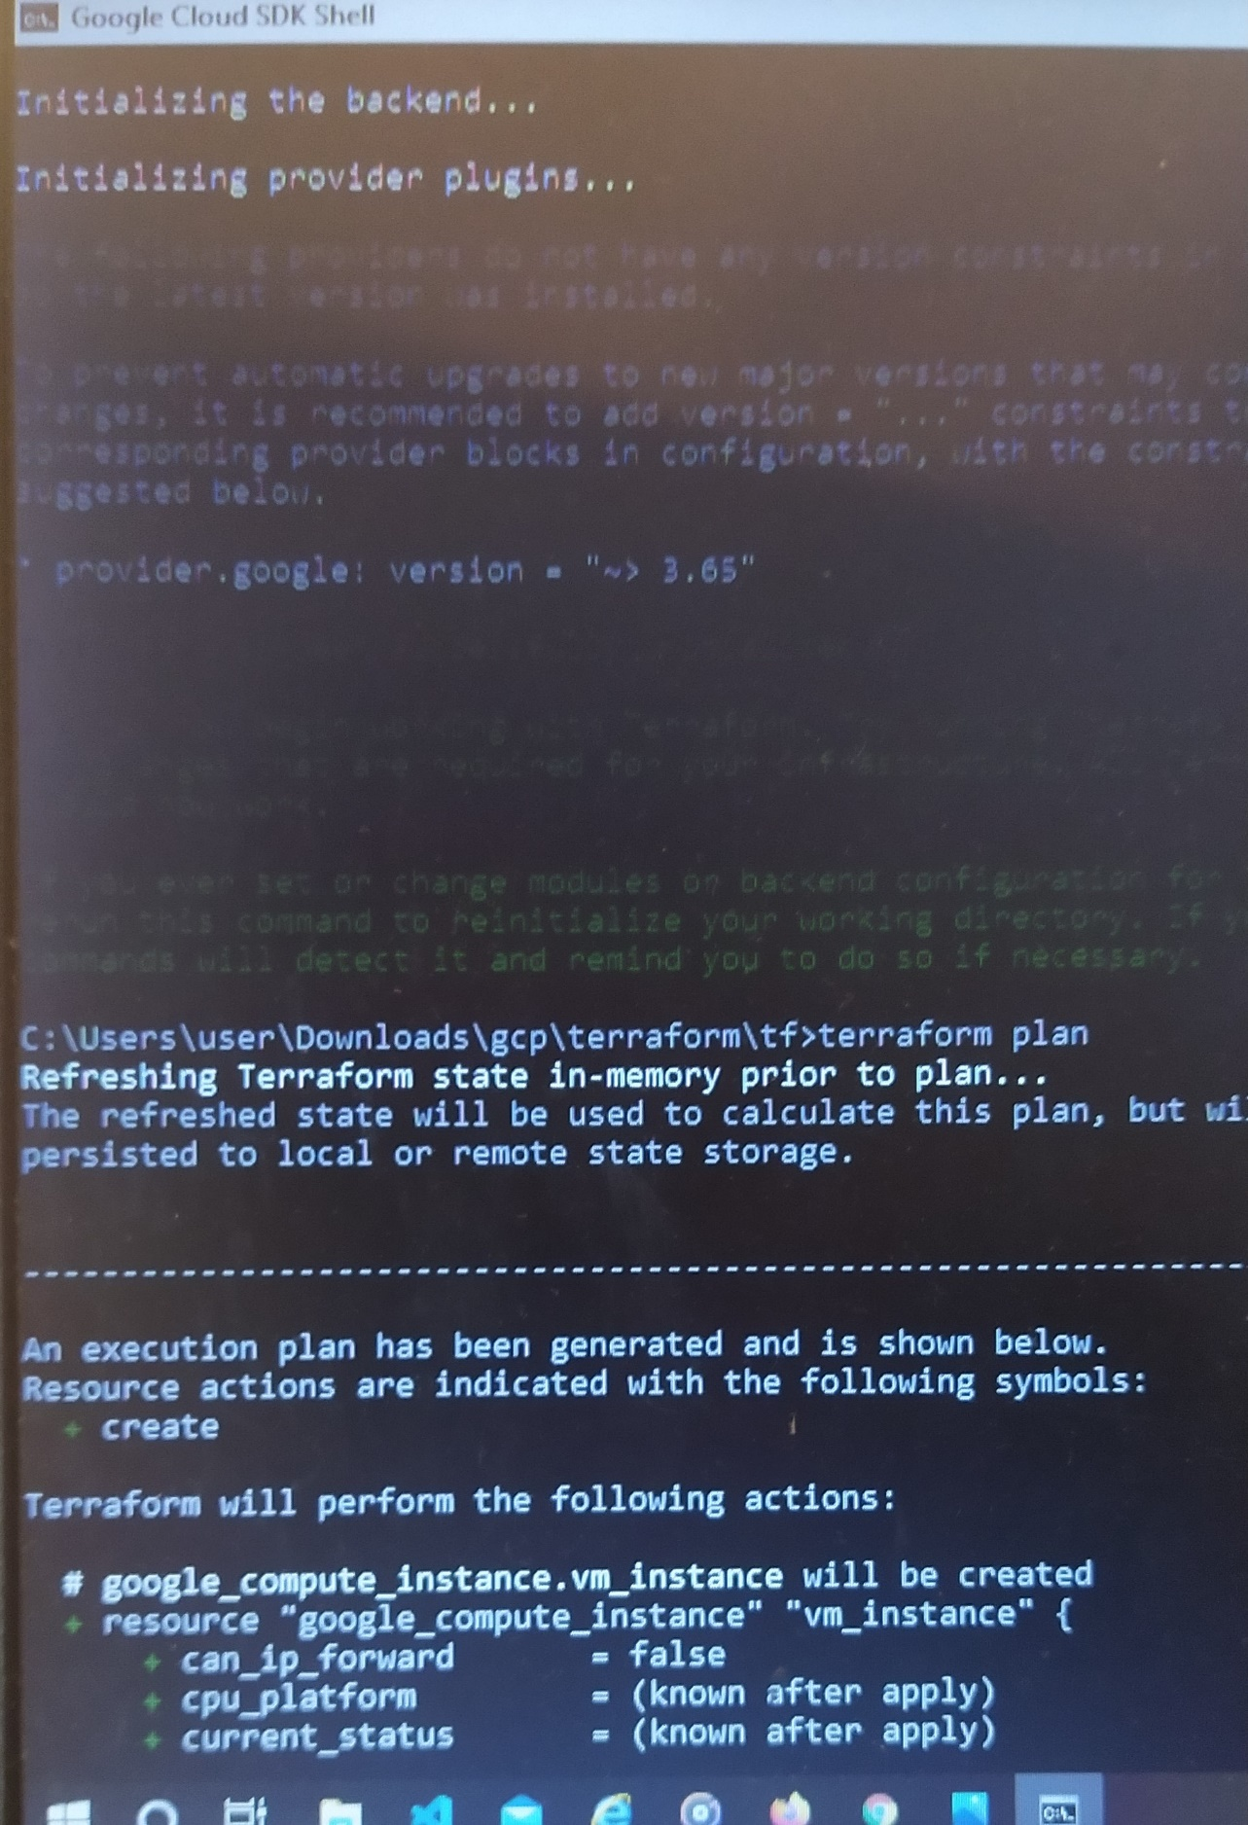

Step 8 : Use ‘terraform apply’ to execute the actions proposed in terraform plan.

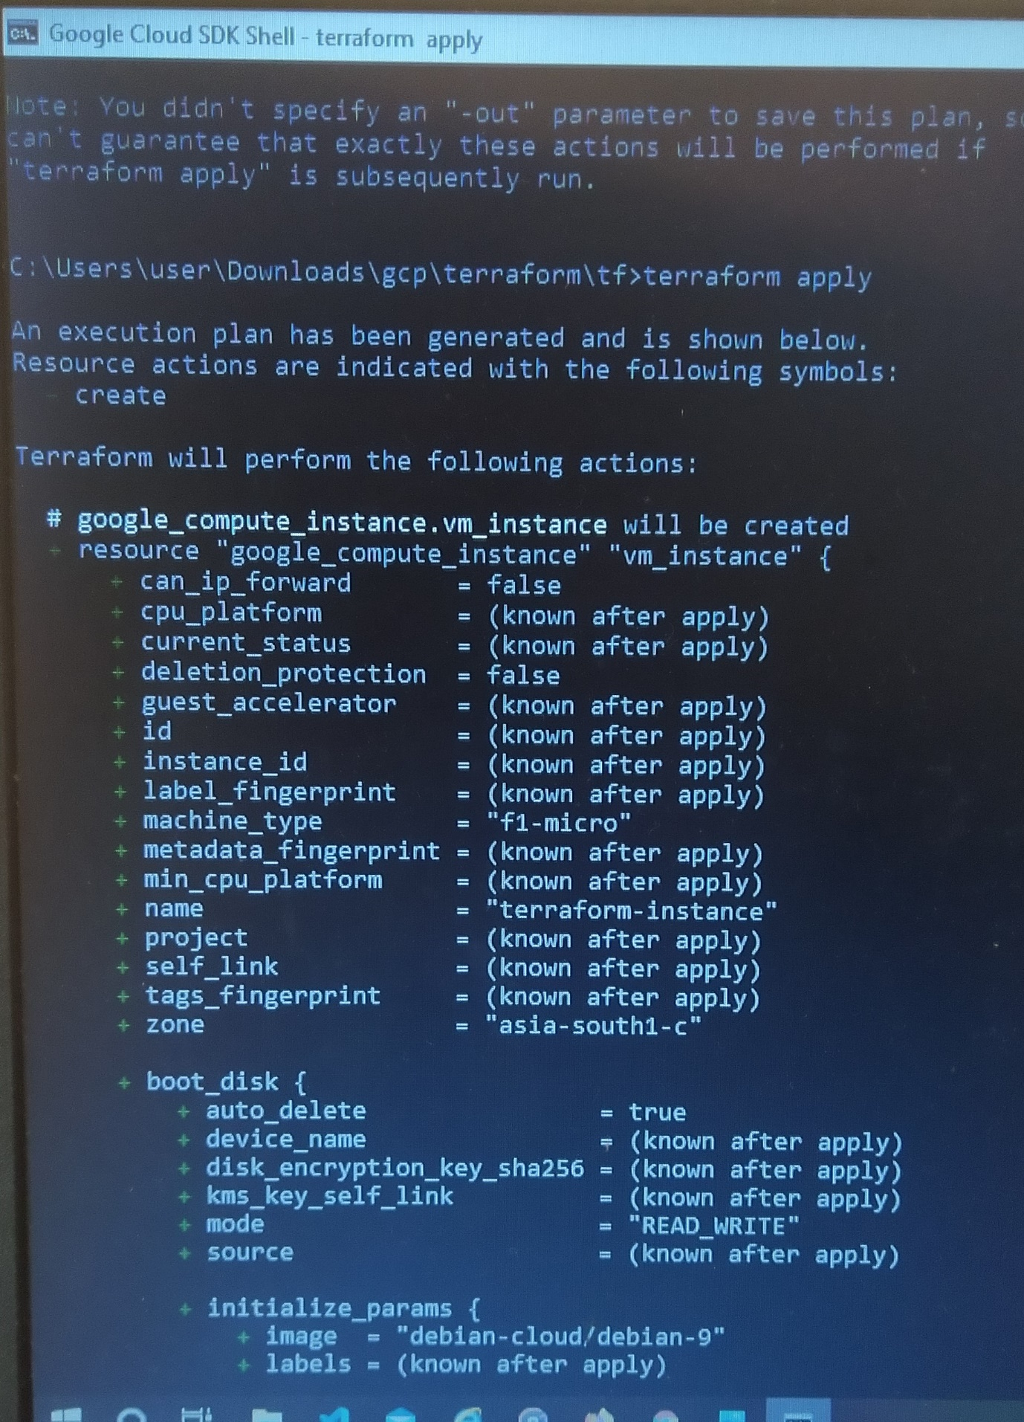

Step 9 : Go to VM instance and check whether the instance is created.

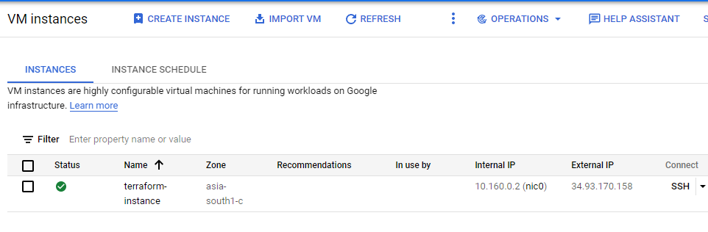

Step 10 : If we want to delete the created instance , use the command ‘terraform destroy’

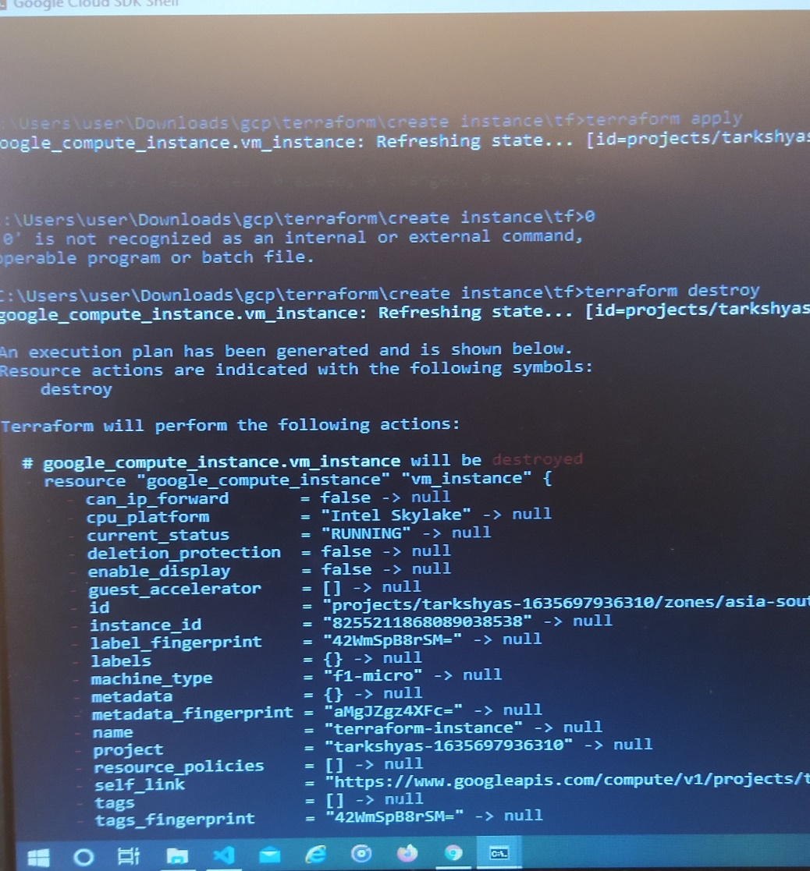

Step 11 : VM instance is deleted.

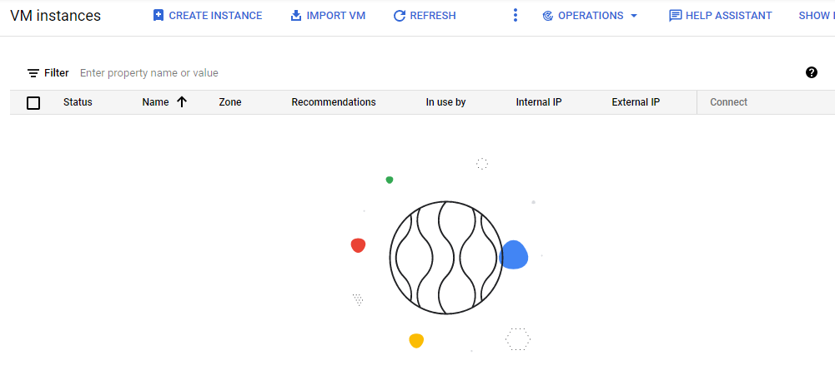

**11.b) Create a SQL instance using terraform**

Step 1 : Create Service account with role as project owner and generate json key for that account . Same as in VM instance creation.





Step 2 : Open VS studio and create files such as provider.tf and sql.tf

Codes inside this files are attached with this document.

Step 3 : Keep the installed terraform , service account key , provider.tf and sql.tf in a same folder

Step 4 : Open cloud sdk and go to the path containing all these files

Step 5 : Now initiate gcloud inside sdk using command ‘init gcloud’



Step 6 : Run terraform init

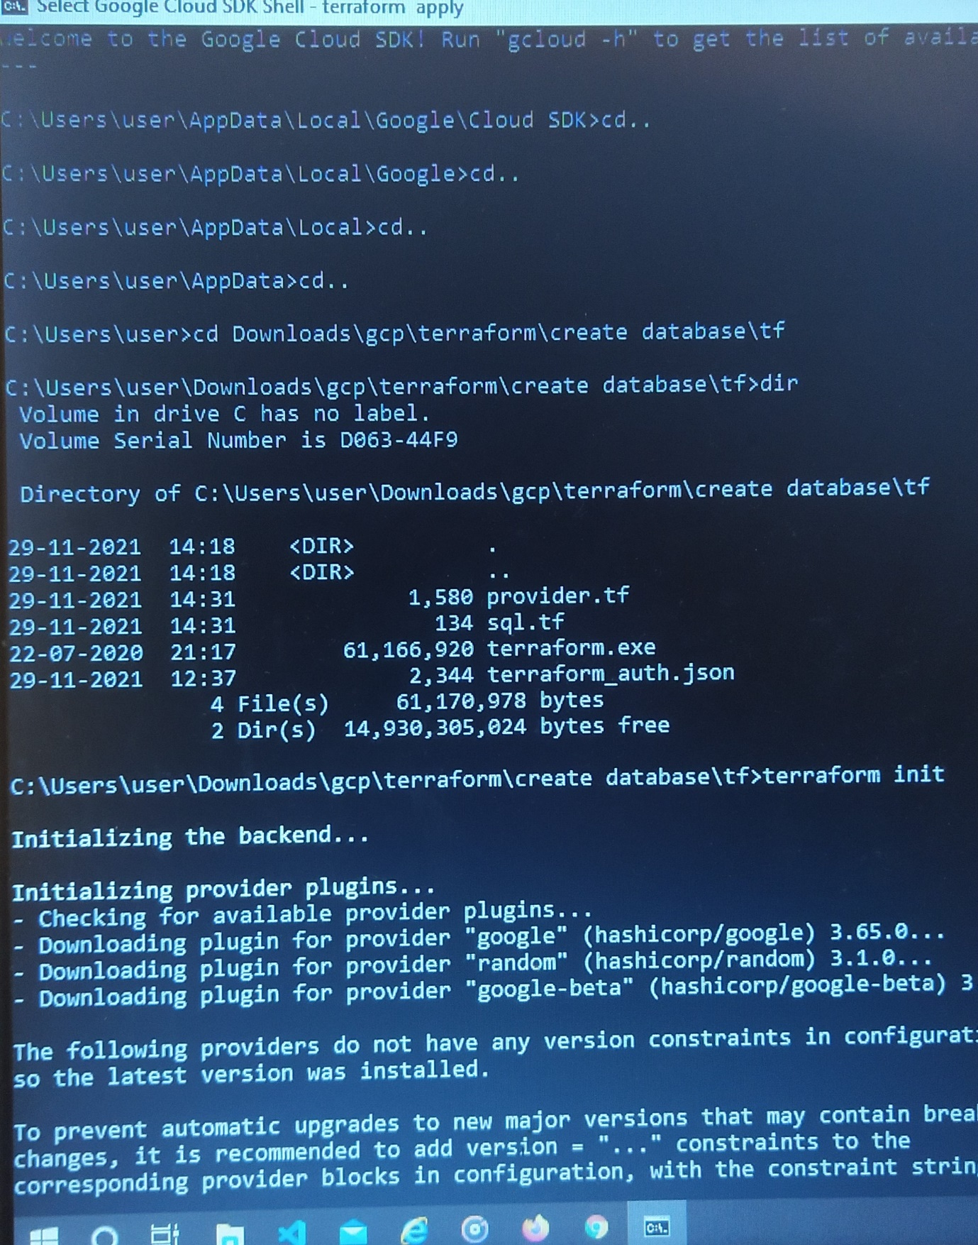

Step 7 : Run terraform plan

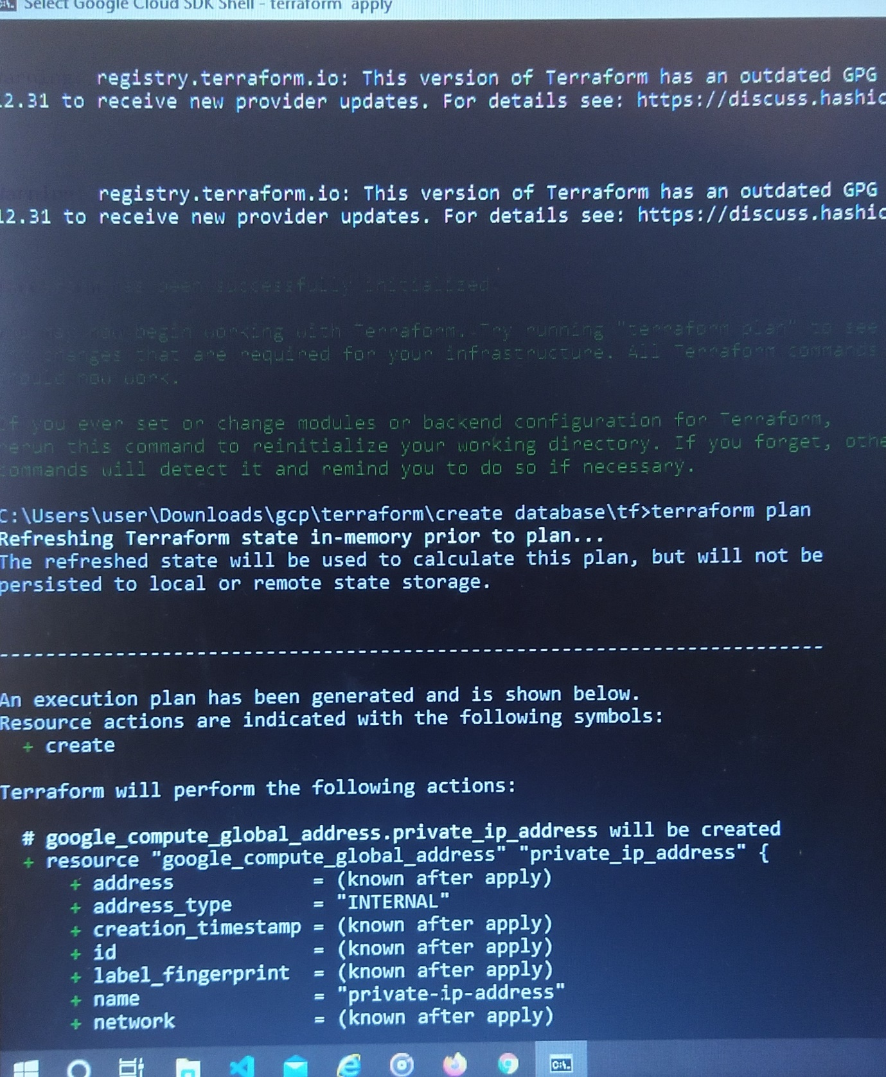

Step 8 : Run terraform apply

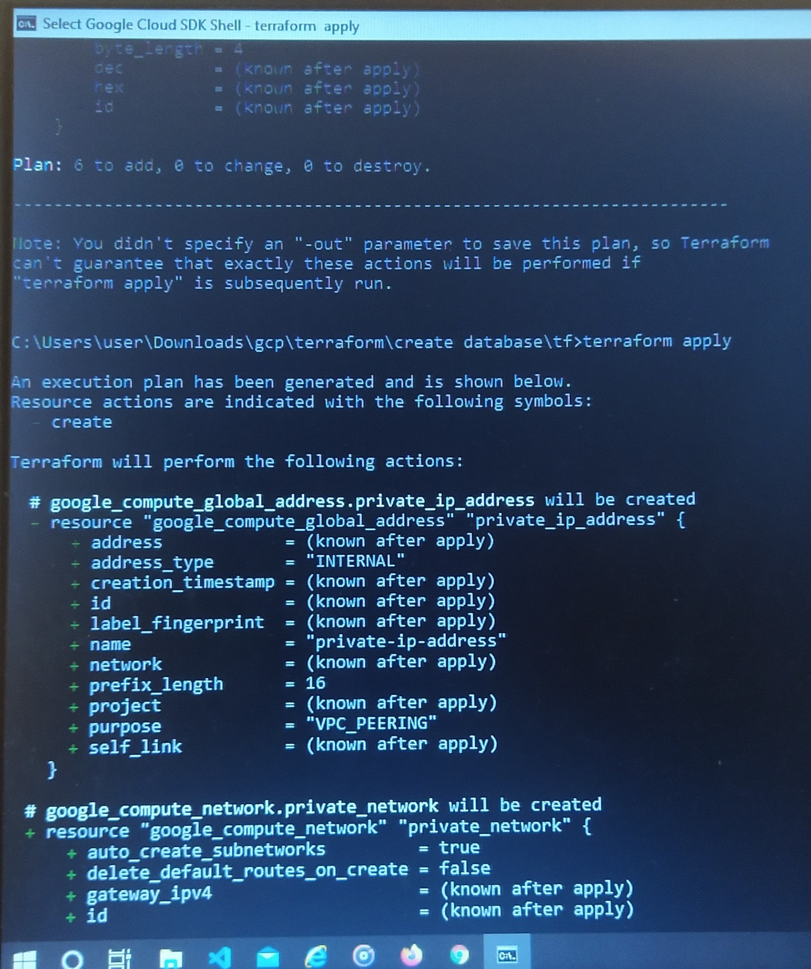

Step 9 : SQL instance created with database

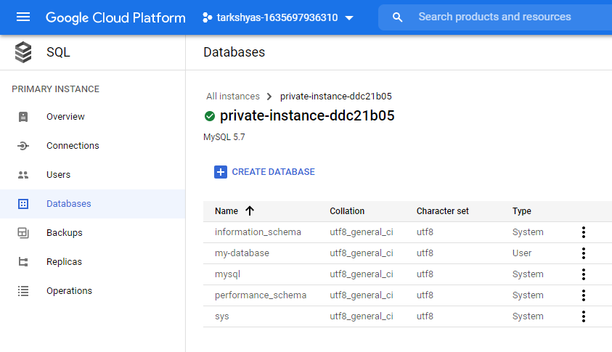

Step 10 : Run terraform destroy

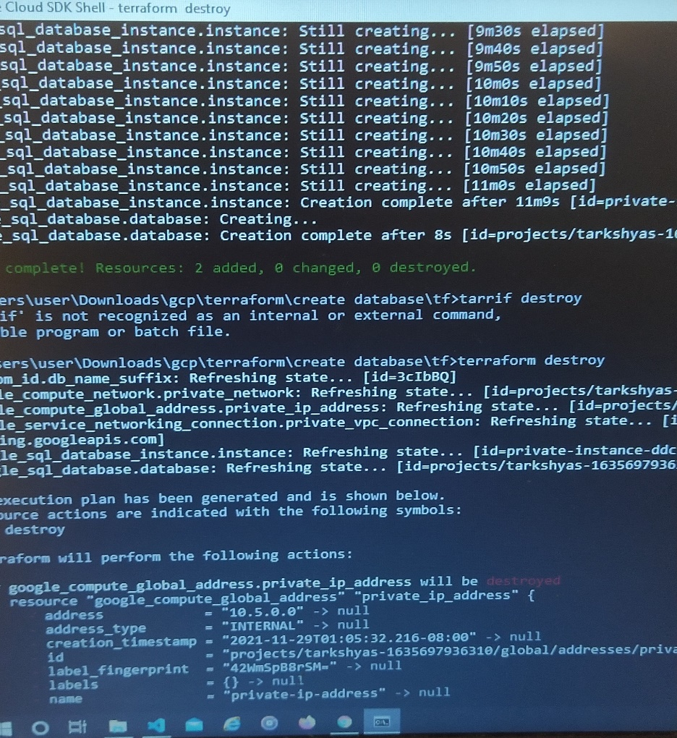

Step 11 : SQL instance deleted

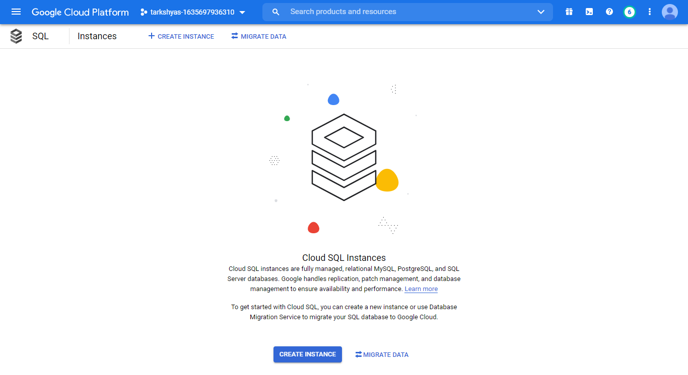

**11.c) Create a VM instance using ansible**

Step 1 : Create Service account with role as project owner and generate json key for that account.



Step 2 : Open the cloud shell terminal and service account key and .yml file

Code containing in the yml file is attatched with this document.

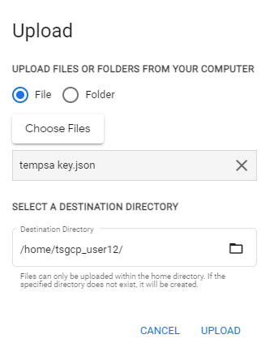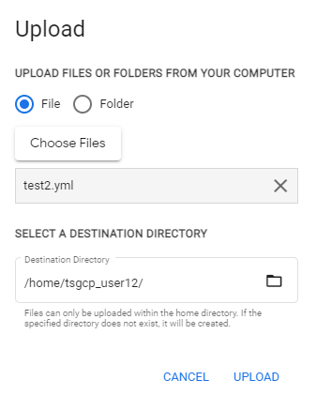

Step 3 : Install ansible version and other google-auth requests in cloud shell using the following codes

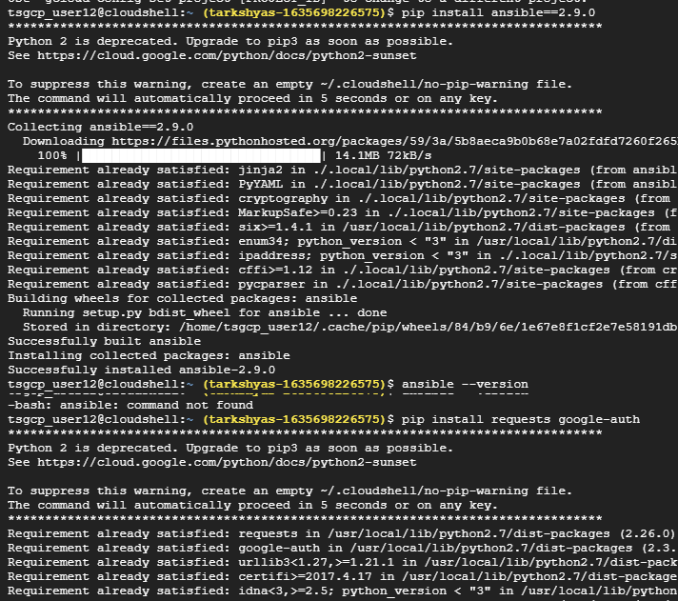

Step 4 : Run ansible-playbook command for creating VM instance

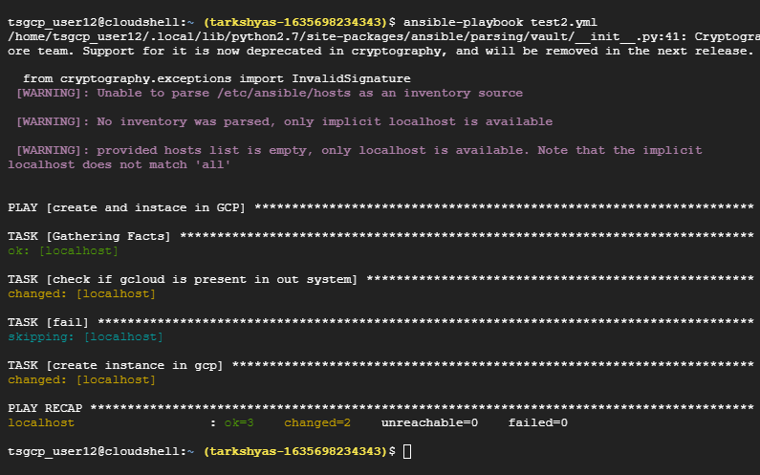

Step 5 : VM instance created successfully

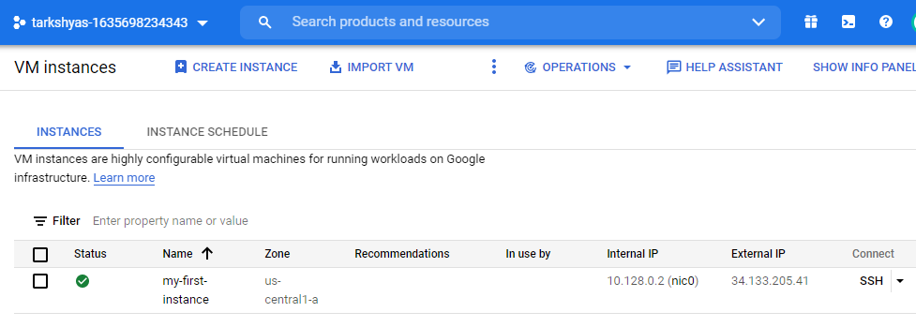

**11.d) Create a SQL instance using ansible**

Step 1 : Create Service account with role as project owner and generate json key for that account.



Step 2 : Open the cloud shell terminal and service account key and .yml file

Code containing in the yml file is attatched with this document.



Step 3 : Install ansible version and other google-auth requests in cloud shell using the following codes. Also install galaxy collections in shell.



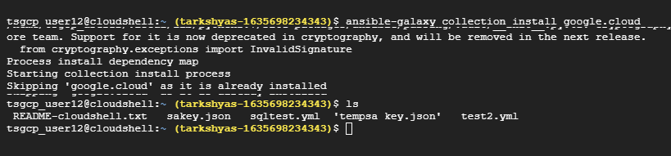

Step 4 : Run ansible-playbook command for creating SQL instance

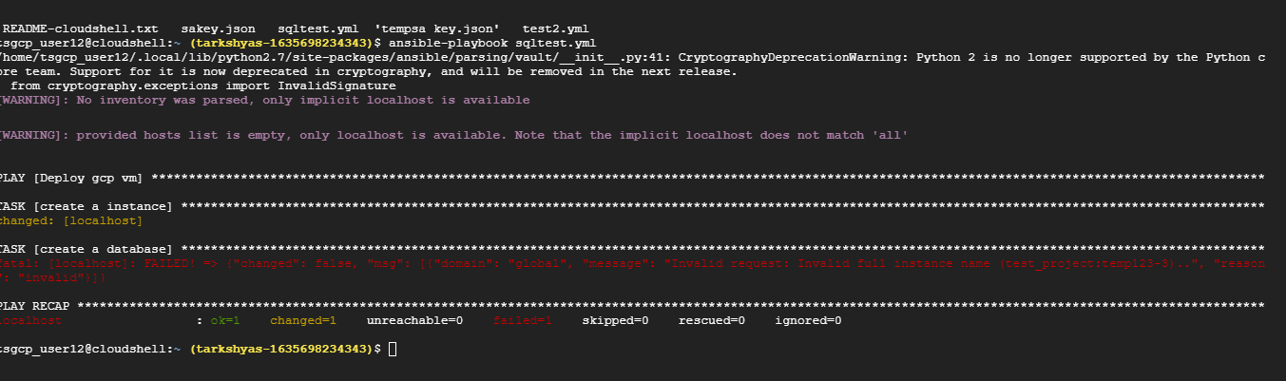

Step 5 : SQL instance with database is reated successfully.

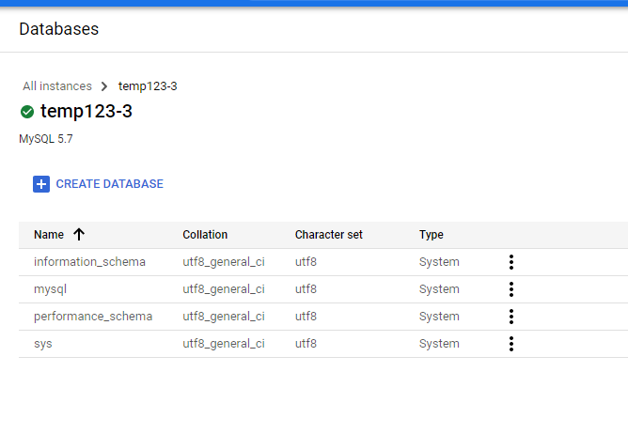

**12.a) Create table in BigQuery and perform various sql operations**

Step 1 : Create a dataset inside project first

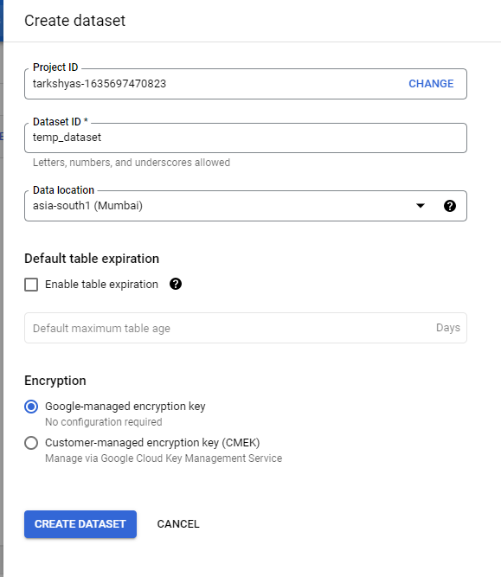

Step 2 : Create a table inside the dataset and upload csv file which contains data. Also we can upload files from cloud storage too.

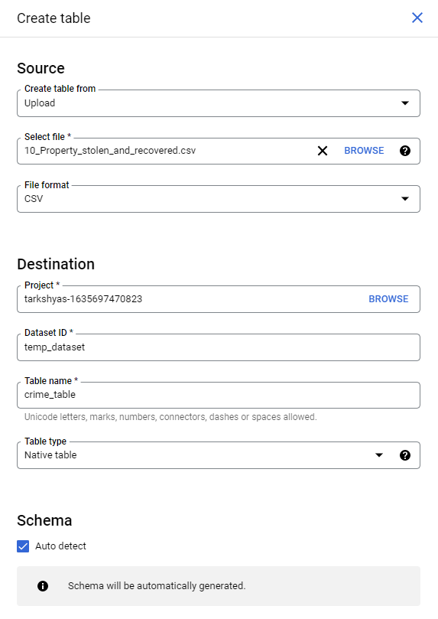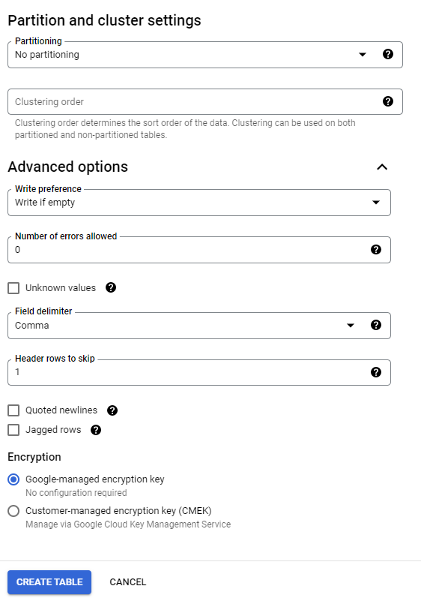

Step 3 : Dataset and table created are,

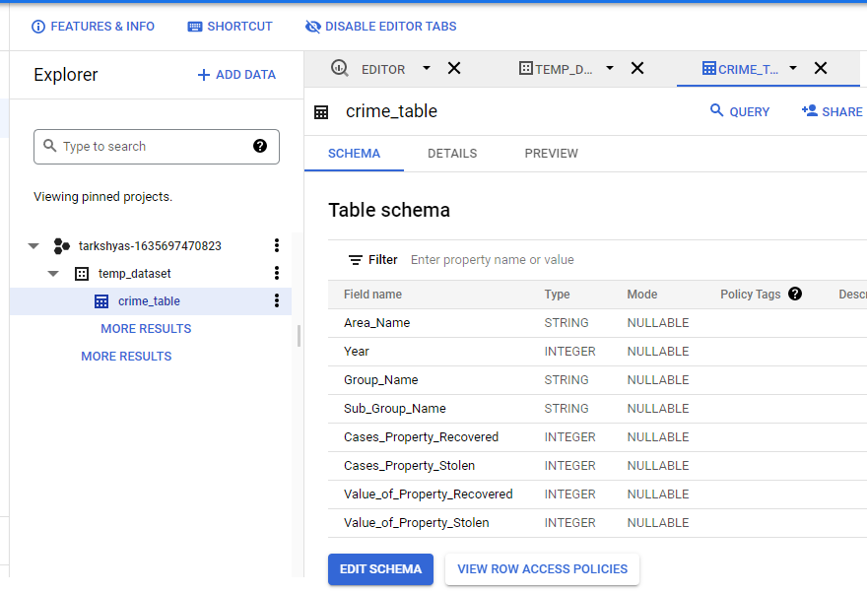

**-- GROUP BY & HAVING --**

Step 4 : Run the query to group data by year,area_name and group_name in the year 2001

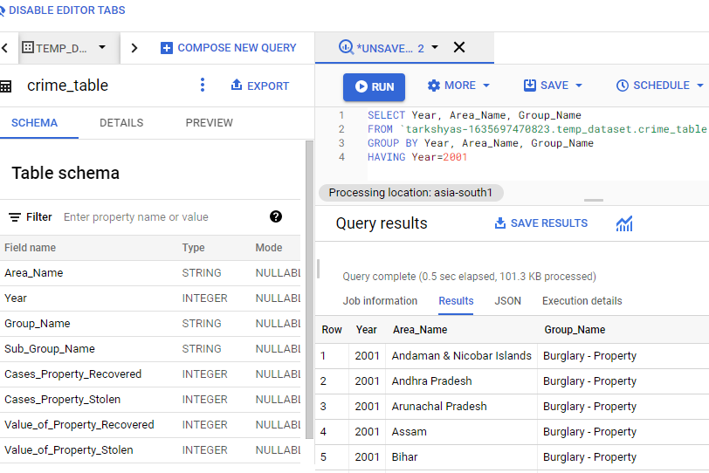

Step 5 : This query result can be stored in a new table ie, result_table

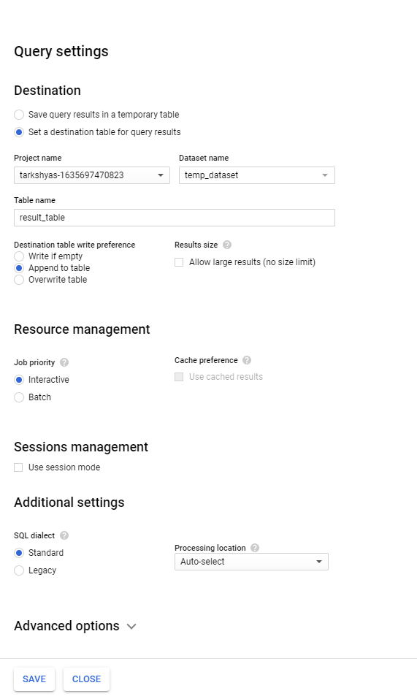

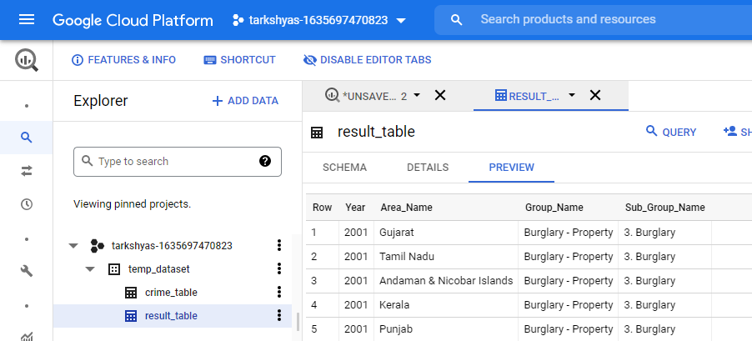

**-- JOIN QUERY --**

Step 6 : Create name table and hour table and join both tables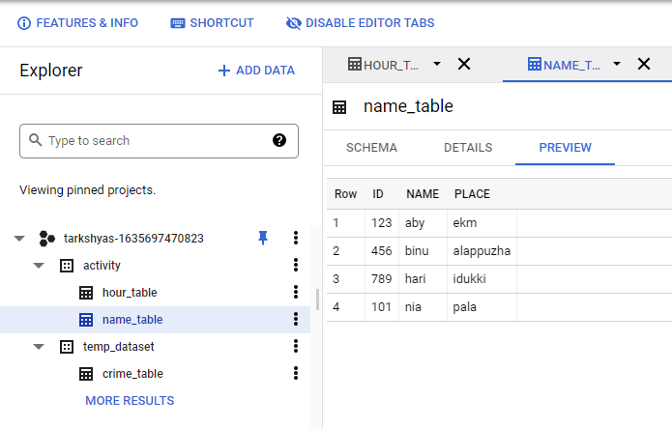

Step 7 : Resultant table after joining

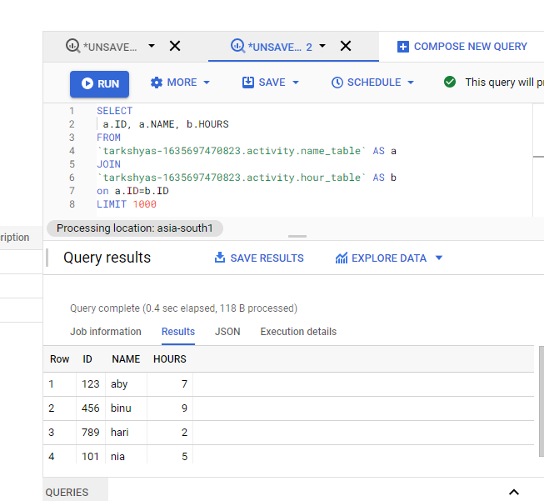

**-- WILD CARD QUERY –**

Step 8 : Create two tables with common names such as student_1 and student_2



Step 9 : After executing the query the resultant table will displays all the contents in both tables.

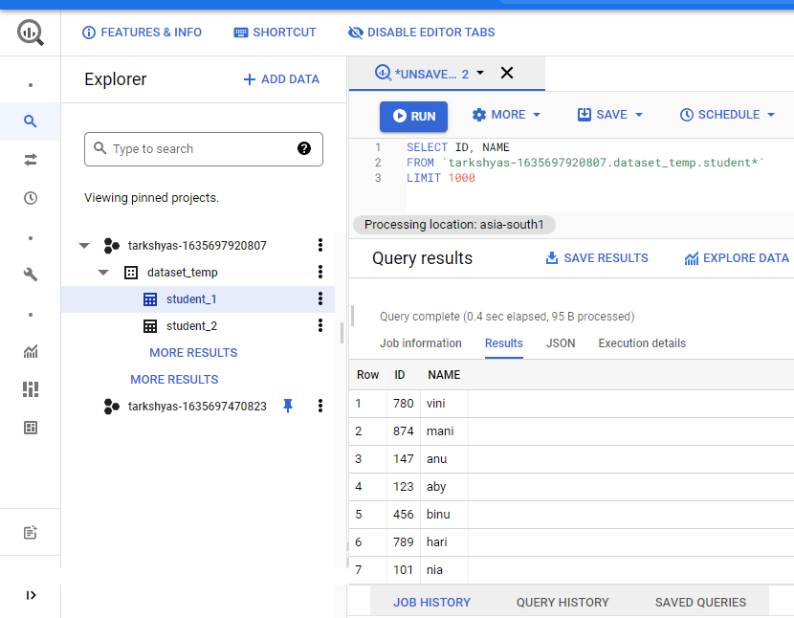

**-- PARTITIONING & CLUSTERING –**

Step 10 : Create dataset and table , then upload file to be partitioned . Here the hacker table contents are :

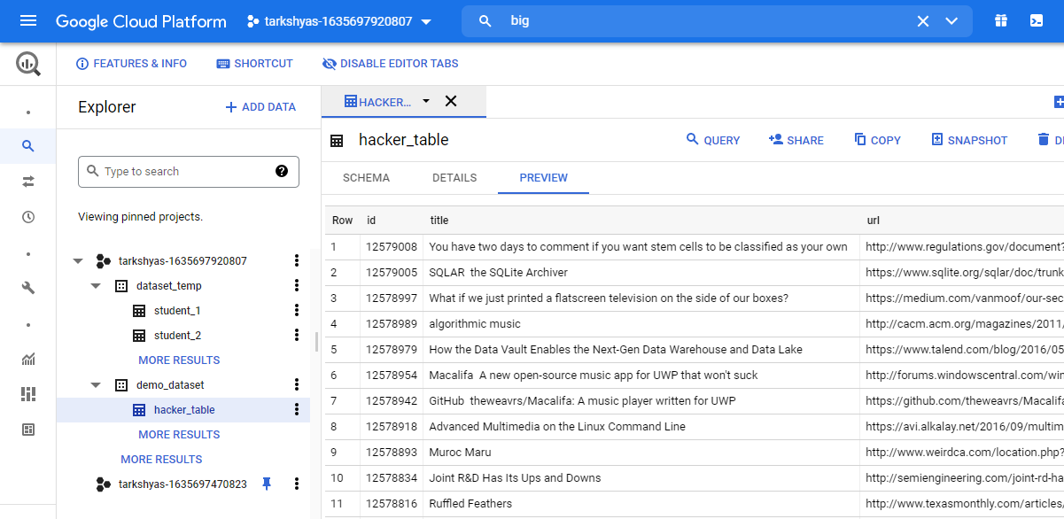

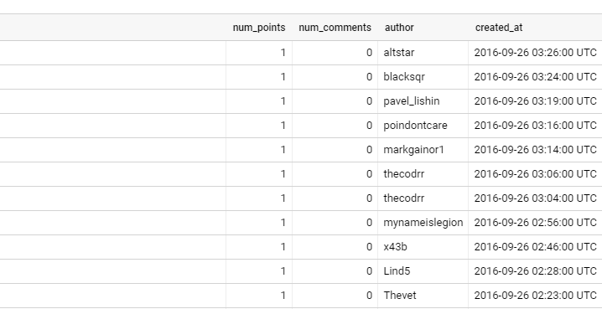

Step 11 : Clean that table so that we need to avoid the time in the row created_at and filter the date only

***Table_1 before cleansing***

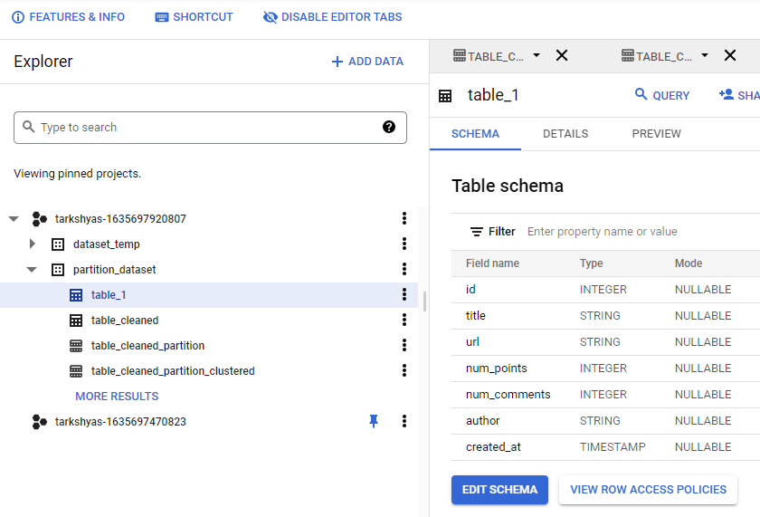

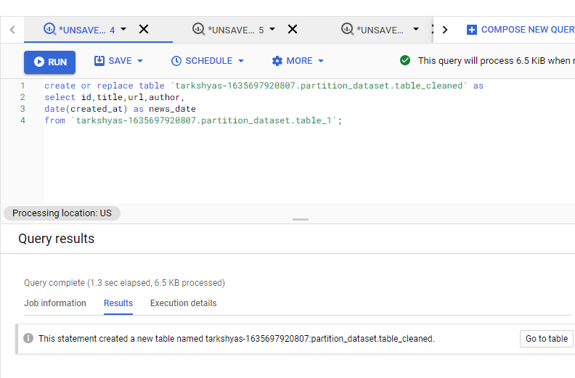

***Table_cleaned***

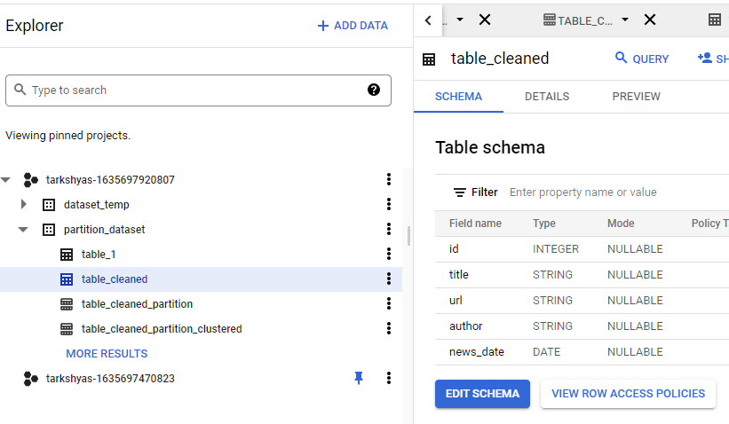

Step 12 : Partition the table based on their news_date so that tables are divided into different groups with similar date

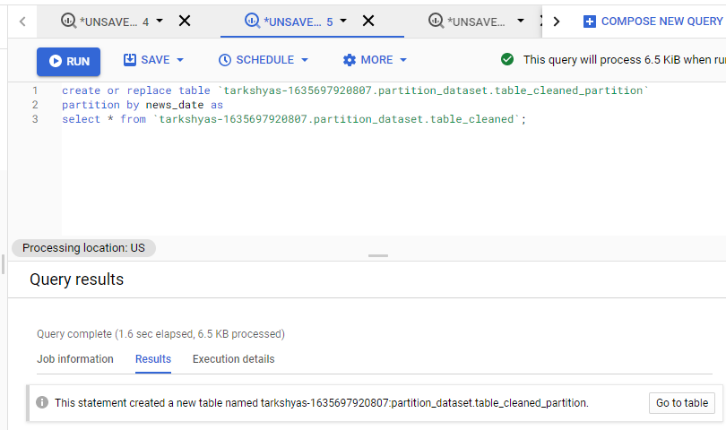

***Partitioned_table***

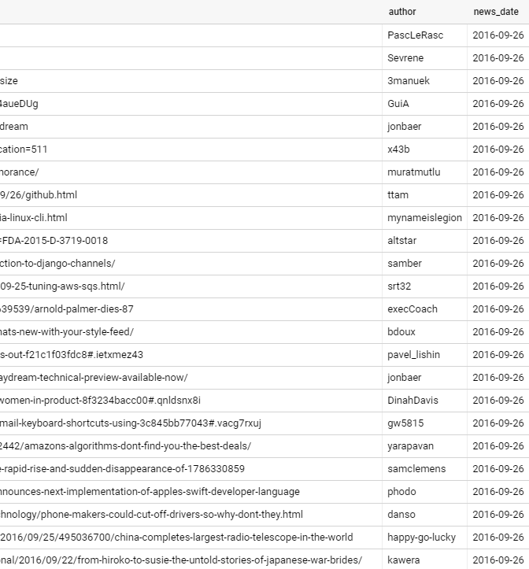

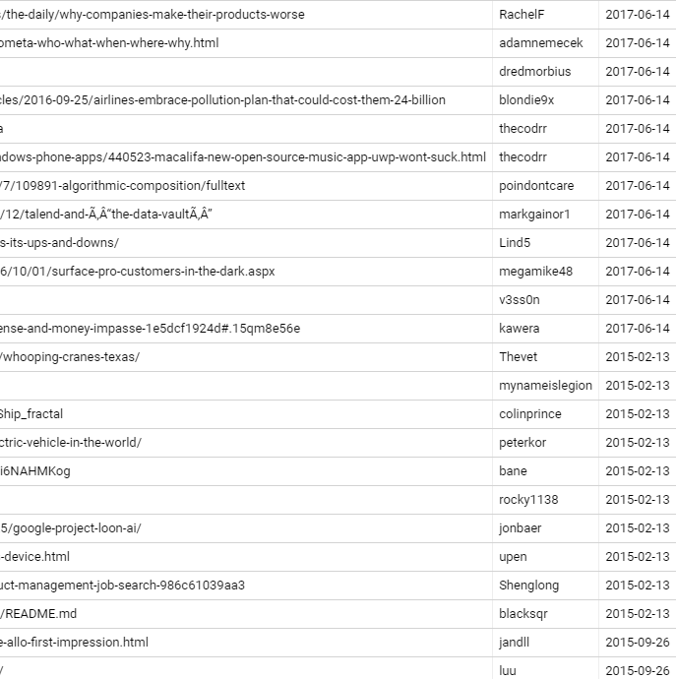

Step 13 : Group together the data with similar author in the partitioned table using cluster query.

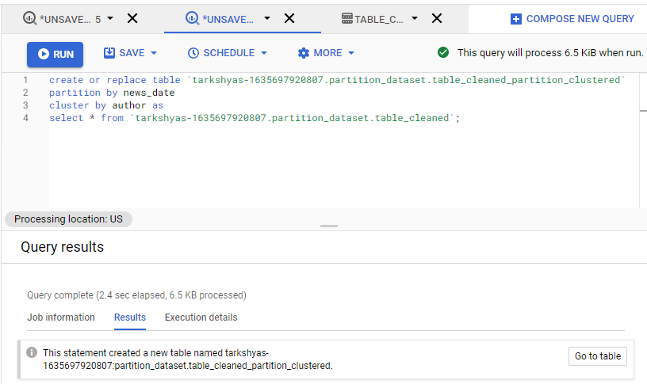

***Clustered_table***

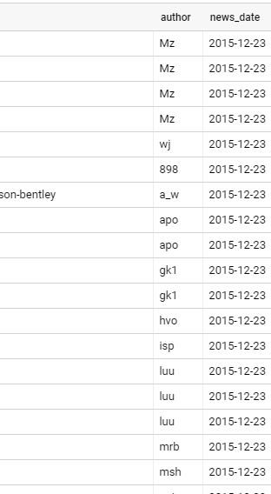

**12.b) Use BigQuery to create machine learning models**

Refer the website : <https://www.qwiklabs.com/focuses/1794?parent=catalog>

Step 1 : Click on the below direct link to bring the public data-to-insights project into BigQuery projects panel :

<https://console.cloud.google.com/bigquery?p=data-to-insights&d=ecommerce&t=web_analytics&page=table>

Step 2 : Table created

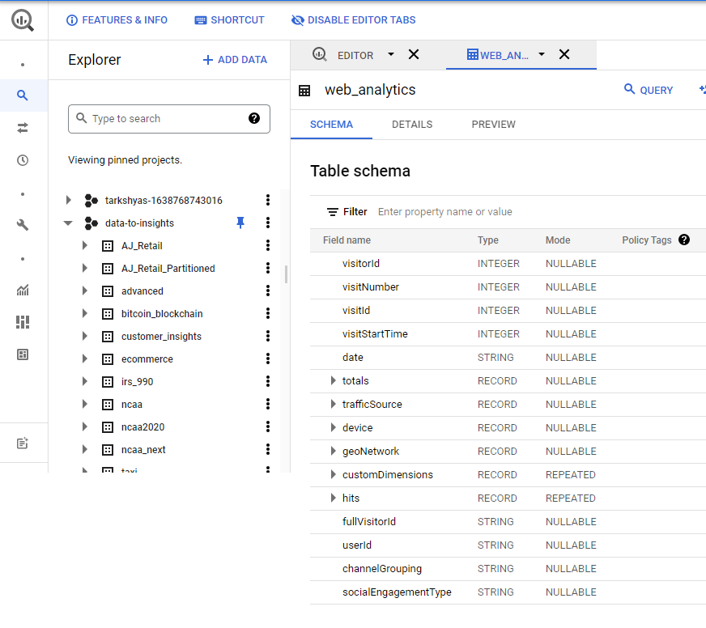

Step 3 : Run queries based on different scenarios

**Question 1:** Out of the total visitors who visited our website, what % made a purchase?

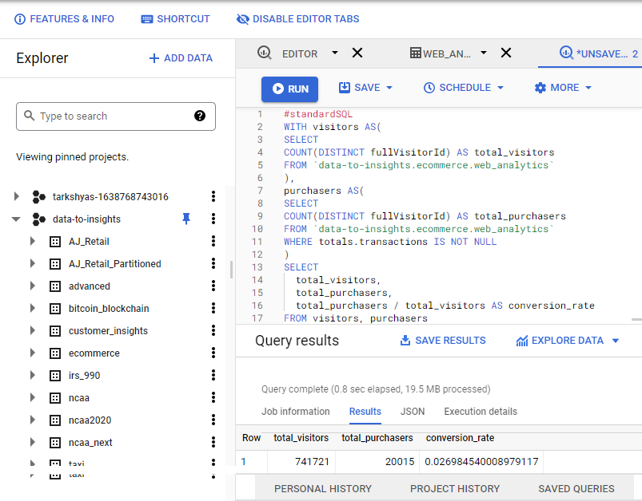

**Question 2:** What are the top 5 selling products?

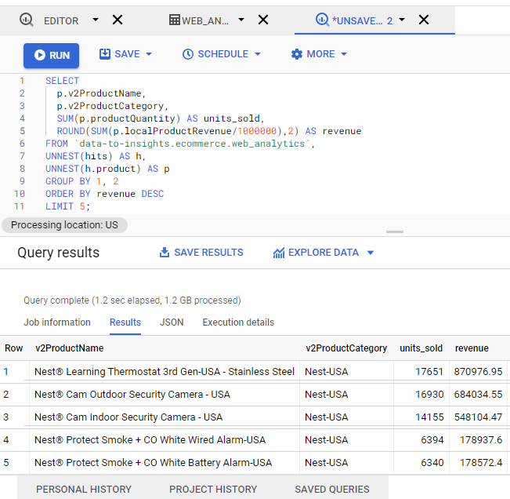

Step 4 : Create ‘ecommerce’ dataset to store models

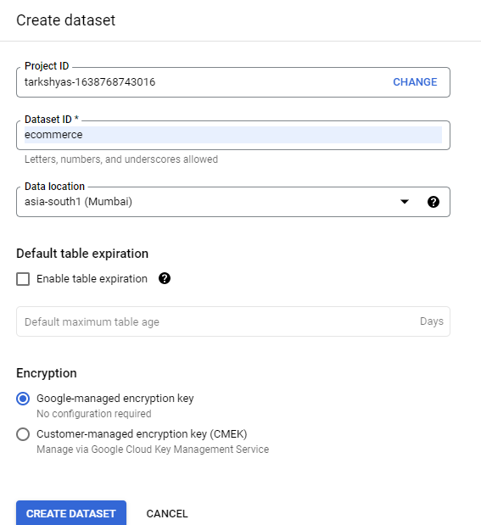

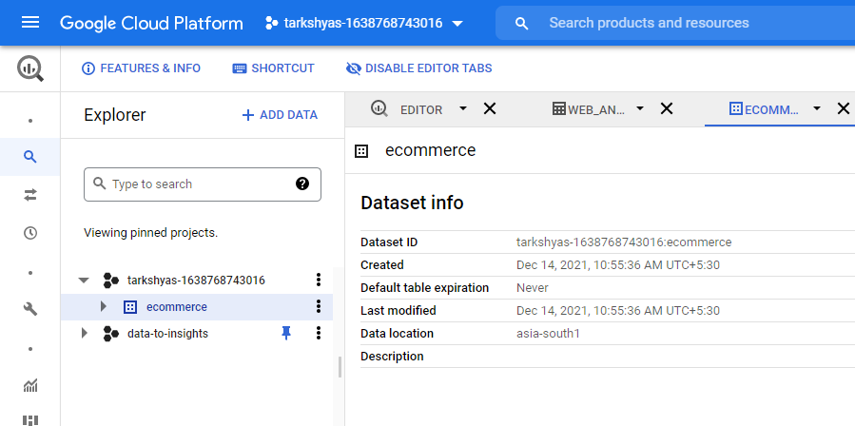

Step 5 : Now we can use logistic_regression in a classification model.

Write query to create the model and specifies model options. Run this query to train the model.

